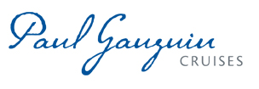
NEW FALL COLLECTION OF TAHITIAN PEARL JEWELRY BY HINERAVA DEBUTS ON THE M/S PAUL GAUGUIN
FEATURING BANGLES, RINGS, NECKLACES, EARRINGS

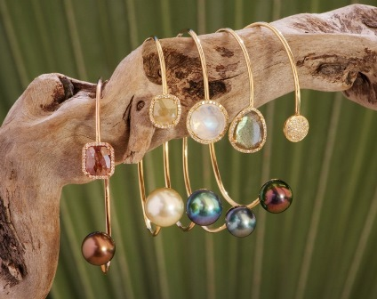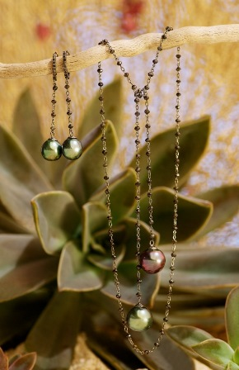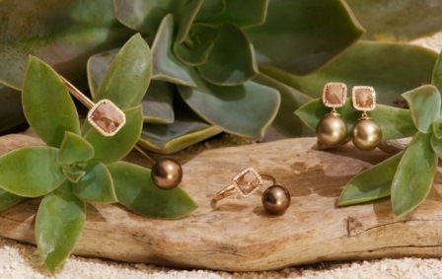

BELLEVUE, WASH. – November 20, 2013 – Paul Gauguin Cruises (www.pgcruises.com), operator of the highest-rated and longest continually sailing luxury cruise ship in the South Pacific, the m/s Paul Gauguin, and the 90-guest m/v Tere Moana, debuts a new fall collection of Tahitian pearl jewelry from designer Kelly Hinerava Bailey of Hinerava. The collection is now available on The Gauguin at its onboard shop La Boutique.

Hinerava is a fresh and contemporary line that focuses on the unique combination of exceptional precious gems with rare colors of Tahitian pearls. Known for one-of-a-kind “island-chic” designs, Hinerava’s fall collection includes bangles, rings, necklaces, and earrings showcasing fall colors that were inspired by irregular and natural beauty as expressed through baroque pearls and organic diamond-slice jewelry.
Bangles include a copper diamond slice and chocolate Tahitian pearl set in rose gold; a canary diamond slice and golden Tahitian pearl set in yellow gold; a diamond bezel moonstone and aqua Tahitian pearl set in yellow gold; a diamond bezel labradorite and silver-blue Tahitian pearl set in yellow gold; and a pave diamond and peacock Tahitian pearl set in yellow gold.
Exclusive Tahitian pearl necklaces feature rare forms of Tahitian baroque pearls. One of the favorites of the collection is a lariat necklace, adorned with black diamonds and harmoniously contrasting Tahitian pearls, which comes with matching earrings.
The collection also showcases jewelry combinations with canary diamond slices set with golden Tahitian pearls in 18K yellow gold with matching earrings and rings along with copper diamond slices set with chocolate Tahitian pearls in 18K rose gold with matching earrings and rings.
Photos of Hinerava’s fall collection can be viewed on Paul Gauguin Cruises’ blog at www.pgcruises.com/blog.
For rates or more information on Paul Gauguin Cruises, please contact a Travel Professional, call 800-848-6172, or visit www.pgcruises.com.
###
About Paul Gauguin Cruises
Owned by Pacific Beachcomber S.C., French Polynesia’s leading luxury hotel and cruise operator, Paul Gauguin Cruises operates the 5+-star cruise ship, the 332-guest m/s Paul Gauguin, providing a deluxe cruise experience tailored to the unparalleled wonders of Tahiti, French Polynesia, the South Pacific, and Southeast Asia. It is one of the top exclusive charter and incentive group venues in the industry and has completed more than 570 South Pacific cruises, serving more than 176,250 guests, including more than 15,000 honeymooners, since its inaugural sail in 1998. The Gauguin’s accolades include recognition as “Top Small-Ship Cruise Line for Families” in Travel + Leisure’s 2013 “World’s Best Awards” and one of the “Top 20 Small Cruise Ships” in 2013 for the 15th year in a row by readers of Condé Nast Traveler.

In December 2012, the m/v Tere Moana began sailing under the Paul Gauguin Cruises banner after completing a multifaceted renovation and offers voyages in the Caribbean, Latin America, and Europe. At 330 feet long and 46 feet wide, The Moana has a draft of 11.5 feet, and accommodates 90 guests with a staff of 60.

Media Contact:
Vanessa Bloy
Paul Gauguin Cruises
Director of Public Relations
(425) 440-6255
vbloy@pgcruises.com

