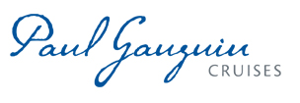
WORLD-RENOWNED OCEANOGRAPHER JEAN-MICHEL COUSTEAU GUEST HOSTS FOUR SAILINGS
ON THE m/s PAUL GAUGUIN IN 2013

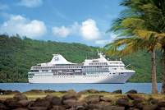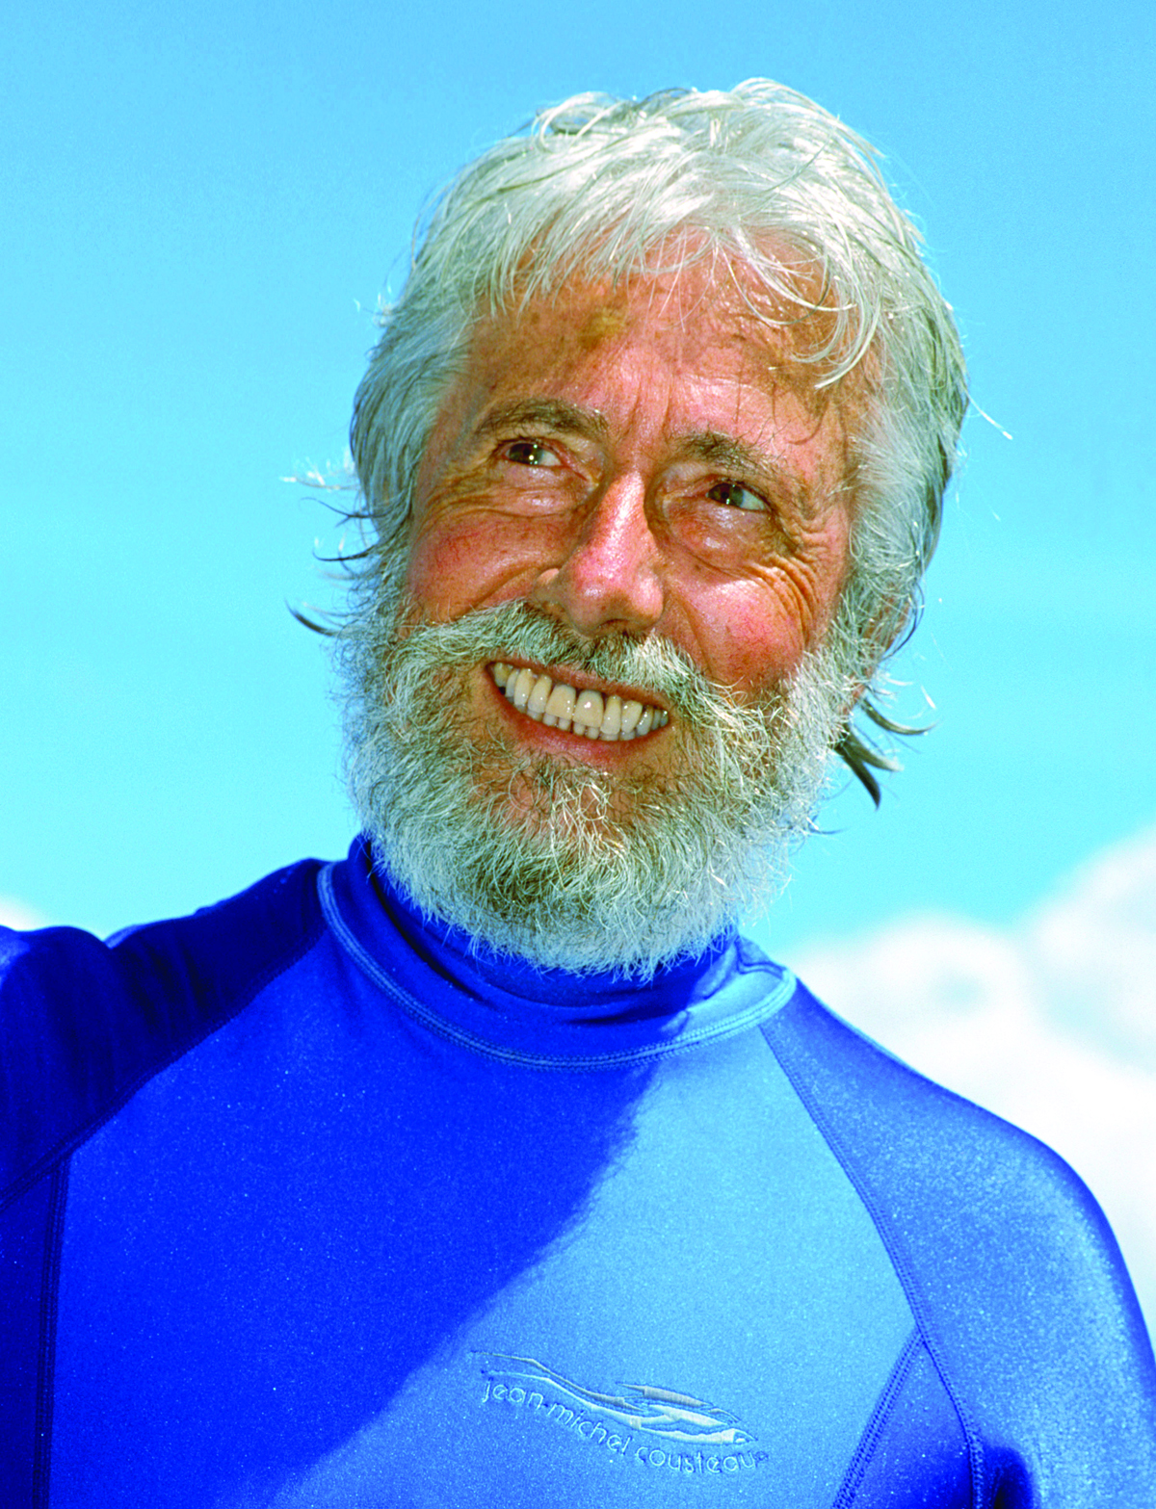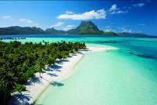

BELLEVUE, WASH. – May 3, 2012 – Paul Gauguin Cruises (www.pgcruises.com), operator of the highest-rated and longest continually sailing luxury cruise ship in the South Pacific, the m/s Paul Gauguin, announces that world-renowned oceanographer and environmentalist Jean-Michel Cousteau will guest host four sailings on The Gauguin in 2013.

Mr. Cousteau is a diplomat for the environment, educator, author, and film producer communicating his passion and concern for the Earth’s oceans. For more than 60 years, he along with his father, the legendary Jacques Cousteau, and his family, have been part of the greatest exploration of the oceans in all of history. In 1999, Mr. Cousteau founded the Ocean Futures Society to explore global oceans, inspiring and educating people throughout the world to act responsibly for their protection, documenting the critical connection between humanity and nature, and celebrating the ocean’s vital importance to the survival of all life on our planet. For more information on Mr. Cousteau and the Ocean Futures Society, visit www.oceanfutures.org.

During voyages on The Gauguin, Mr. Cousteau will offer a series of lectures with videos of his work in the world’s oceans and accompany guests on several dives.

Voyages Featuring Guest Host Jean-Michel Cousteau:
- 14-night Marquesas, Tuamotus & Society Islands Cruise: February 2, 2013
- 10-night Society Islands & Tuamotus Cruise: June 26, 2013
- 11-night Australs & Society Islands Cruise: September 21, 2013
- 11-night Cook Islands & Society Islands Cruise: November 2, 2013
Also available in 2013 is Mr. Cousteau’s Ambassadors of the Environment Youth Program which introduces young travelers (ages 9-17) to the natural wonders of French Polynesia through interactive, hands-on experiences with island ecosystems. The program is available on sailings from June through August and on select holiday cruises for a nominal fee of $299 per child.
For rates and reservations for Paul Gauguin Cruises, contact a professional travel agent, call 800-848-6172, or visit www.pgcruises.com.
###

About Paul Gauguin Cruises
Owned by Pacific Beachcomber S.C., French Polynesia’s leading luxury hotel and cruise operator, Paul Gauguin Cruises operates the 5+-star cruise ship m/s Paul Gauguin, providing a deluxe cruise experience tailored to the unparalleled wonders of Tahiti, French Polynesia, and the South Pacific. The Gauguin was built at the Chantiers de l’Atlantique shipyard in Saint Nazaire, France. The ship, 513 feet long and 71 feet wide, has a draft of 16.9 feet, and can accommodate 332 guests with a staff of 217. It is one of the top Exclusive Charter and Incentive Group venues in the industry and has completed more than 570 South Pacific cruises, serving more than 176,250 guests, including more than 15,000 honeymooners, since its inaugural sail in 1998. The Gauguin has undergone more than $25 million in enhancements, with an additional $7 million completed in January 2012. The Gauguin has been impressively named the 2011 Silver Magellan Award Winner in the Small Cruise Ship category by Travel Weekly and was recognized as one of the “Top 20 Small Cruise Ships” by readers of Condé Nast Traveler in 2012.

The cruise line’s second ship, the m/v Tere Moana, will begin sailing under the Paul Gauguin Cruises’ banner in December 2012 after completing a multifaceted renovation. The ship, which will sail Europe, the Caribbean, and Latin America, is 330 feet long and 46 feet wide, has a draft of 11.5 feet, and can accommodate 90 guests with a staff of 54.

For additional information on Paul Gauguin Cruises, please visit www.pgcruises.com.
Media Contact:
Paul Gauguin Cruises
Vanessa Bloy, Director of Public Relations
(425) 440-6255
vbloy@pgcruises.com

