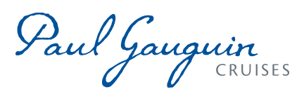

PAUL GAUGUIN CRUISES UNVEILS RENOVATED M/S PAUL GAUGUIN

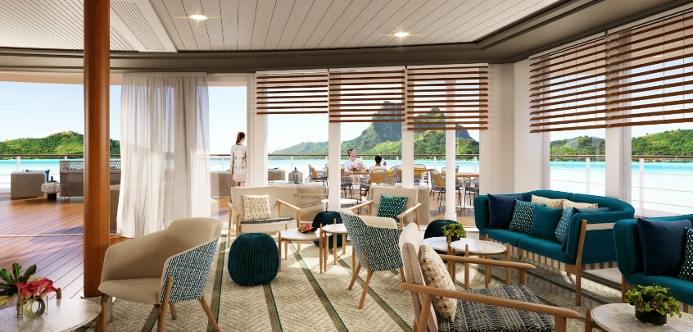
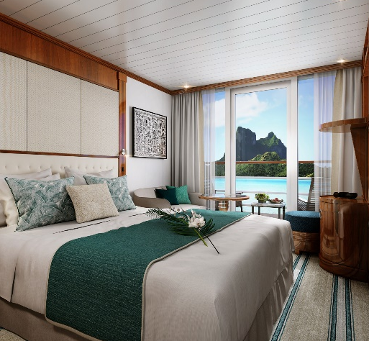

BELLEVUE, Wash. – March 17, 2021 – Paul Gauguin Cruises, operator of the highest-rated and longest continually sailing luxury cruise ship in the South Pacific, the m/s Paul Gauguin, is pleased to announce a ship renovation, featuring luxurious enhancements, that took place during The Gauguin’s drydock ending on March 9th in Singapore.
The vision of the renovation was to enhance The Gauguin’s elegant Polynesian signature with a chic and fresh style to enrich guests’ experience sailing the islands of Tahiti, French Polynesia, Fiji and the South Pacific.

Large Environmental Upgrades in line with Paul Gauguin Cruises’ Values
Minimizing the impact on the environment is one of the highest priorities of the company. In 2019, Paul Gauguin Cruises took two major measures in this field. The line completely eliminated the use of heavy fuel oil by using a much cleaner fuel (LS MGO – Low-Sulphur Marine Gas Oil) and also committed to offsetting 150 percent of its carbon emissions. The Gauguin’s most recent environmental upgrades follow this path and include water treatment and consumption optimization along with energy-saving initiatives.

An Empowering Experience Dedicated to Guests’ Highest Expectations
The Gauguin is outfitted with a look designed by Studio Jean-Philippe Nuel that evokes South Seas elegance and the storied islands that the iconic ship sails. The refurbishment enhances the historical interior of the vessel made of warm and dark woodworks and strengthens the local identity. The fresh palette incorporates lagoon shades, a wide range of green and natural tones, warm color touches, organic patterns and woven textiles. Exotic panoramas and traditional artwork transports guests into the local environment. All The Gauguin’s staterooms and suites, as well as the public spaces, were renovated: Le Grand Salon, three restaurants, Piano Bar, La Palette Lounge, Spa and Salon, Boutique, Pool Deck, and Reception area.

Ongoing Onboard Upgrades
To accompany The Gauguin’s renovation, amenities were enhanced for a full guest experience. Guests will be able to enjoy complimentary unlimited Wi-Fi and a virtual museum of over 150 paintings of artist Paul Gauguin during their voyage. These new enhancements will provide guests of The Gauguin an even more luxurious, all-inclusive experience, which encompasses dining in all three of the ship’s restaurants and 24-hour room service; complimentary beverages including select wines, beer, and spirits; and onboard gratuities for room stewards and dining staff.

The Gauguin’s Polynesian Signature
Paul Gauguin Cruises was created to provide enjoyable, meaningful, and authentic experiences with the communities, cultures, and natural wonders that make Tahiti, French Polynesia, and the South Pacific so alluring. Every detail of The Gauguin’s renovations reflect her home including the ship’s décor, artwork, special Polynesian dishes in the restaurants, enrichment programming, and cultural activities aboard led by Les Gauguines and Les Gauguins, the ship’s troupe of Tahitian ambassadors and entertainers.

Itineraries following the renovations include: 10-night Society Islands & Tuamotus; 11-night Cook Islands & Society Islands; 7-night Tahiti & the Society Islands; and 14-night Marquesas, Tuamotus & Society Islands voyages. Guests have exclusive access to the line’s private island Motu Mahana, and a private beach in Bora Bora. Paul Gauguin Cruises offers a wide range of outdoor activities embracing the natural wonders of the South Pacific such as snorkeling, kayaking, paddleboarding, and SCUBA diving excursions.

For more information on Paul Gauguin Cruises, or to check cruise fares, please contact a Travel Advisor, call 800-848-6172, or visit www.pgcruises.com.
###

About Paul Gauguin Cruises
Paul Gauguin Cruises operates the 5+-star cruise ship, the 332-guest m/s Paul Gauguin, providing a deluxe cruise experience tailored to the unparalleled wonders of Tahiti, French Polynesia, and the South Pacific. Paul Gauguin Cruises has been recognized by notable publications in travel and lifestyle. One of the “Top Small Cruise Lines” in the Condé Nast Traveler 2020 Readers’ Choice Awards and is honored on the publication’s 2020 “Gold List.” Paul Gauguin Cruises was selected as “Best Small-Ship Cruise Line” in Global Traveler’s Leisure Lifestyle Awards from 2016 to 2020. Recently the line was recognized for the fourth time for having the “Best French Polynesia Cruises” in the AFAR Travelers’ Choice Awards. In September 2019, Paul Gauguin Cruises joined PONANT’s family, the world leader of small-ship cruising.

About Jean-Philippe Nuel
From a family of architects passionate about design and contemporary creations, Jean-Philippe Nuel graduated as an architect from the École des Beaux-Arts in Paris and quickly made a name for himself by winning several competitions, including an international competition presided over by Kenzo Tange. After a first hotel project in Paris, subsequent iconic projects for upscale international hotel chains (InterContinental Lyon and Marseille, Molitor Swimming Pool, La Clé Champs Elysées in Paris, Sofitel Roma Villa Borghese) and many boutique hotels followed (for example Le Cinq Codet, Le Damantin, Le Belleval in Paris). Jean-Philippe Nuel has been collaborating with French luxury expedition cruise line PONANT, since 2010 and and won the AHEAD Europe Design award 2019 for the design of Le Champlain, second vessel in the PONANT EXPLORER series he signed for the Company.

Media Contact:
Paul Gauguin Cruises
Public Relations Department
mediarelations@pgcruises.com

Images Credit: ©Paul Gauguin Cruises/Studio Jean-Philippe NUEL
Link to Images: https://www.dropbox.com/sh/7elddrbjnvlb73g/AABW0EQ8eiqbVVlzCHke4XNSa?dl=0

