PAUL GAUGUIN CRUISES COMPLETES $7 MILLION RENOVATION
Largest Renovation in the Ship’s 14-Year History

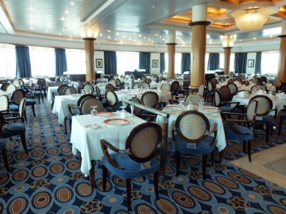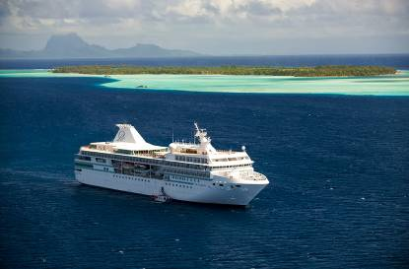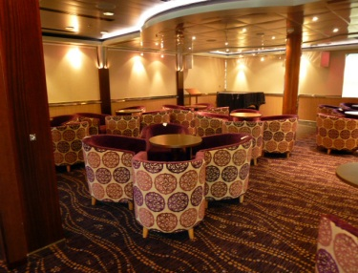

BELLEVUE, WASH. – February 17, 2012 – Paul Gauguin Cruises (www.pgcruises.com), operator of the highest-rated and longest continually sailing luxury cruise ship in the South Pacific, the m/s Paul Gauguin, is proud to reveal the completion of a $7 million renovation – the largest in the ship’s 14-year history. The renovation took place during the ship’s 10-night crossing from Tahiti to Brisbane, Australia, as well as during the 11-night drydock that followed, when extensive enhancements were made to both the interiors and exteriors of The Gauguin.

Renovations throughout the ship include new flooring and replaced carpeting, elegant new furniture, new window treatments and decorative wall panels, and new signage, providing a lighter, brighter feel.

Additionally, all suites and staterooms feature new teak railings on the balconies and new bathroom flooring. On the culinary front, La Veranda offers guests a redesigned entrance, refinished indoor and outdoor furniture, and solar shades throughout. Le Grill boasts new decorative partitions and divider walls, as well as a new buffet area and new lighting. L’Etoile also features a redesigned entrance in addition to video equipment for conferences.

Promenade Deck 5 boasts a new built-in banquette and expanded casino in Le Casino, and Deck 6 received a new integrated display case for books and art. La Palette features a decorative stone band along the front of the bar and an updated lighting system, as well as new outdoor furniture. Le Grand Salon and La Palette offer refurbished dance floors to provide the perfect venue to dance the night away.

Guests now cruise aboard a vessel that has been thoroughly updated and redecorated for even greater luxury and comfort, reflecting Paul Gauguin Cruises’ level of commitment to the ship and the importance of the overall guest experience.
###
About Paul Gauguin Cruises
Owned by Pacific Beachcomber S.C., French Polynesia’s leading luxury hotel and cruise operator, Paul Gauguin Cruises operates the 5+-star cruise ship m/s Paul Gauguin, providing a deluxe cruise experience tailored to the unparalleled wonders of Tahiti, French Polynesia, and the South Pacific. The Gauguin was built at the Chantiers de l’Atlantique shipyard in Saint Nazaire, France. The ship, 513 feet long and 71 feet wide, has a draft of 16.9 feet and can accommodate 332 guests with a staff of 217. It is one of the top Exclusive Charter and Incentive Group venues in the industry and has completed more than 570 South Pacific cruises, serving more than 176,250 guests, including more than 15,000 honeymooners, since its inaugural sail in 1998. The Gauguin has undergone more than $25 million in enhancements, with an additional $7 million completed in January 2012. The Gauguin has been impressively named the 2011 Silver Magellan Award Winner in the Small Cruise Ship category by Travel Weekly and earned the “#1 ranking for Dining” in the Small Ship Category in Cruise Critic’s 2011 Cruisers’ Choice Awards.

Paul Gauguin Cruises also recently announced the acquisition of a second ship, which will begin sailing under the Paul Gauguin Cruises banner in December 2012. With plans to sail to the Mediterranean, Caribbean, and Latin America, this ship will be christened m/v Tere Moana after completing a multifaceted renovation in December 2012. The Moana features 45 staterooms accommodating 90 guests.

For additional information on Paul Gauguin Cruises, please visit www.pgcruises.com.
Media Contact:
Paul Gauguin Cruises
Vanessa Bloy, Director of Public Relations
(425) 440-6255
vbloy@pgcruises.com

