PAUL GAUGUIN CRUISES 2018 HOLIDAY VOYAGES FEATURE PARADISE IN THE SOUTH PACIFIC

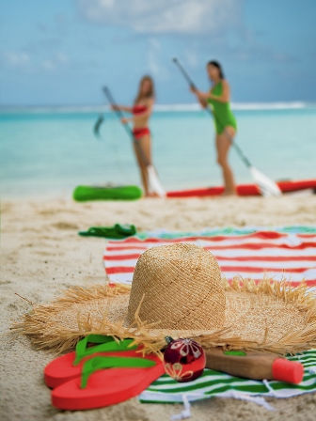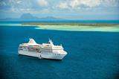

BELLEVUE, WASH. – July 25, 2018 – Paul Gauguin Cruises (www.pgcruises.com), operator of the highest-rated and longest continually sailing luxury cruise ship in the South Pacific, the m/s Paul Gauguin, features two 7-night Tahiti & the Society Islands voyages on The Gauguin offering the perfect way to celebrate December holidays in paradise.

On The Gauguin’s December 22, 2018, voyage, guests can enjoy the Christmas holiday on French Polynesia’s white-sand beaches, or they can ring in the New Year on the South Seas in festive style during the December 29, 2018, cruise.

The 7-night Tahiti & the Society Islands holiday cruises depart Papeete, Tahiti, and sail to Huahine, Taha’a (Motu Mahana), Bora Bora (overnight), and Moorea (overnight) in the Society Islands. In addition to cruising to beautiful islands in French Polynesia and highlighting Polynesian culture, these voyages feature complimentary access to Paul Gauguin Cruises’ two exclusive retreats—Motu Mahana, an islet off the coast of Taha’a, and a private beach in Bora Bora. At Motu Mahana, guests enjoy a day of watersports, Polynesian activities, a barbecue feast, and cocktails from full-service and floating bars. In Bora Bora, guests can relax on a white-sand beach and enjoy refreshments, a game of volleyball, and snorkeling in crystal-clear waters.
Both holiday voyages feature the Stewards of Nature family program, which invites guests to discover and value nature through hands-on, interactive learning for children and teens ages 7-17, as well as family members. Every day of the cruise, there is a combination of naturalist-led island and/or beach excursions, science activities, crafts, games, and other adventures. Depending on the itinerary, children might learn about underwater life during a snorkeling excursion, observe the ocean or the stars through binoculars or an onboard telescope, learn about different kinds of marine life and their habitats, reinforce their discoveries by playing Ocean Trivia or Oceanopoly, go on a dolphin-watching expedition, swim with sharks and rays, play beach games and race hermit crabs, enjoy a dance performance or a movie and a pizza party on board, and learn what it means to be a Steward of Nature. While all of the activities on the itinerary are included for children and teens through a nominal fee, family members are invited and encouraged to participate in most activities for the additional cost of the shore excursions.

For more information on Paul Gauguin Cruises, contact a Travel Professional, call 800-848-6172, or visit www.pgcruises.com.
###
About Paul Gauguin Cruises
Owned by Pacific Beachcomber S.C., French Polynesia’s leading luxury hotel and cruise operator, Paul Gauguin Cruises operates the 5+-star cruise ship, the 332-guest m/s Paul Gauguin, providing a deluxe cruise experience tailored to the unparalleled wonders of Tahiti, French Polynesia, and the South Pacific. Paul Gauguin Cruises has been recognized by notable publications in travel and lifestyle and was voted “#1 Midsize-Ship Ocean Cruise Line” by readers in the Travel + Leisure World’s Best Awards 2017†. The line was also recognized as one of the “Top Small Cruise Lines” in the Condé Nast Traveler 2017 Readers’ Choice Awards and is honored on the publication’s 2018 “Gold List.” Paul Gauguin Cruises was also selected as “Best Small-Ship Cruise Line” in Global Traveler’s Leisure Lifestyle Awards in 2016, 2017, and 2018, and received top honors as the “#1 Cruise Line for Honeymooners” in BRIDES Magazine’s 2017 Honeymoon Awards and was listed in the publication’s “Top All-Inclusives” in the 2018 Honeymoon Awards.

Media Contact:
Paul Gauguin Cruises
Vanessa Bloy, Director of Public Relations
(425) 440-6255/ vbloy@pgcruises.com

†From Travel + Leisure Magazine, August 2017 © Time Inc. Affluent Media Group. Used under license. Travel + Leisure and Time Inc. Affluent Media Group are not affiliated with, and do not endorse products or services of, Paul Gauguin Cruises.

