PAUL GAUGUIN CRUISES ANNOUNCES 2018 VOYAGES IN TAHITI, FRENCH POLYNESIA & THE SOUTH PACIFIC
NEW DESTINATION OF TAHITI ITI OFFERED ON SELECT VOYAGES

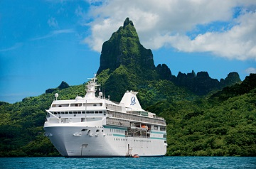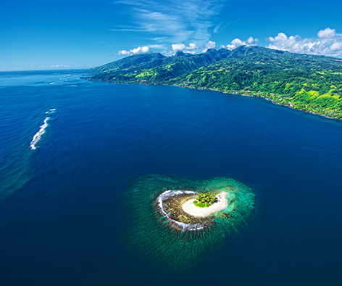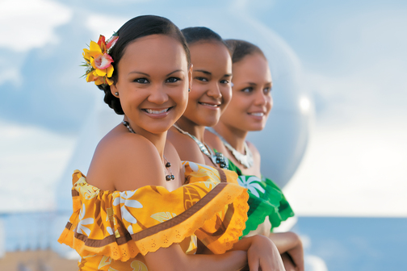

BELLEVUE, WASH. – October 20, 2016 – Paul Gauguin Cruises (www.pgcruises.com), operator of the highest-rated and longest continually sailing luxury cruise ship in the South Pacific, the m/s Paul Gauguin, is pleased to announce its 2018 voyages in Tahiti, French Polynesia, and the South Pacific.

In 2018, Paul Gauguin Cruises will be the first cruise line to visit the port city of Vairao in Tahiti Iti, which is the smaller of two landmasses that comprise the island of Tahiti and offers a wild coastline, ancient petroglyphs, marae (temples), Polynesian culture, and surfing fame. Tahiti Iti is scheduled on 7-night Society Islands & Tahiti Iti voyages and a special sailing of the 10-night Society Islands & Tuamotus itinerary.

The Gauguin will also be showcasing its most sought-after itineraries in 2018: the 7-night Tahiti & the Society Islands; 7-night Tahiti, the Society Islands & Tuamotus; 10-night Society Islands & Tuamotus; 11-night Cook Islands & Society Islands; and 14-night Marquesas, Tuamotus & Society Islands.

Designed specifically to sail the pristine lagoons of these islands, The Gauguin provides an up-close, authentic experience of the South Seas and offers an elegant yet casual ambiance with luxurious accommodations, gourmet dining, trademark Polynesian hospitality, and extraordinary all-inclusive value. On all 2018 sailings, guests also receive complimentary access to Paul Gauguin Cruises’ two exclusive retreats. Off the coast of Taha’a lies the islet of Motu Mahana, where guests can enjoy a day of watersports, Polynesian activities, a sumptuous barbecue feast, and cocktails from a floating bar. In Bora Bora, guests can relax on a private, white-sand beach and enjoy refreshments, a game of volleyball, and snorkeling in crystal-clear waters.

Again in 2018, Paul Gauguin Cruises’ partnership with the Wildlife Conservation Society (WCS) offers two interactive, educational programs to enrich guests’ experience on board. During the summer months and holiday season, Stewards of Nature is offered and invites children ages 7 to 17, as well as their families, to discover and value nature through hands-on interactive learning. The Wildlife Discovery Series is an onboard lecture program focusing on the environment and wildlife of our planet presented by some of the world’s most fascinating conservationists, scientists, and oceanographers.

To launch its 2018 voyages, Paul Gauguin Cruises is offering savings of 50% off standard cruise fares on all voyages, plus included airfare from Los Angeles.

For rates or more information on Paul Gauguin Cruises, please contact a Travel Professional, call 800-848-6172, or visit www.pgcruises.com.
###
About Paul Gauguin Cruises
Owned by Pacific Beachcomber S.C., French Polynesia’s leading luxury hotel and cruise operator, Paul Gauguin Cruises operates the 5+-star cruise ship, the 332-guest m/s Paul Gauguin, providing a deluxe cruise experience tailored to the unparalleled wonders of Tahiti, French Polynesia, and the South Pacific. Paul Gauguin Cruises accolades include being voted #2 in the category of “Top Small Cruise Lines” in the Condé Nast Traveler 2015 Readers’ Choice Awards and recognition on the publication’s 2016 “Gold List.” In addition, the line was voted by Travel + Leisure readers “#1 Small-Ship Cruise Line” and “#1 Small-Ship Cruise Line for Families” in the Travel + Leisure 2014 World’s Best Awards. Recently, readers voted Paul Gauguin Cruises “#1 Midsize-Ship Ocean Cruise Line” in the Travel + Leisure World’s Best Awards 2016.†
Media Contact:
Paul Gauguin Cruises
Vanessa Bloy, Director of Public Relations
(425) 440-6255
vbloy@pgcruises.com

†From Travel + Leisure, August 2016 ©2016 Time Inc. Affluent Media Group. Used under license. Travel + Leisure and Time Inc. Affluent Media Group are not affiliated with, and do not endorse products or services of Paul Gauguin Cruises.

