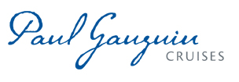
PAUL GAUGUIN CRUISES ANNOUNCES 2018 LINE-UP OF WILDLIFE DISCOVERY SERIES LECTURERS

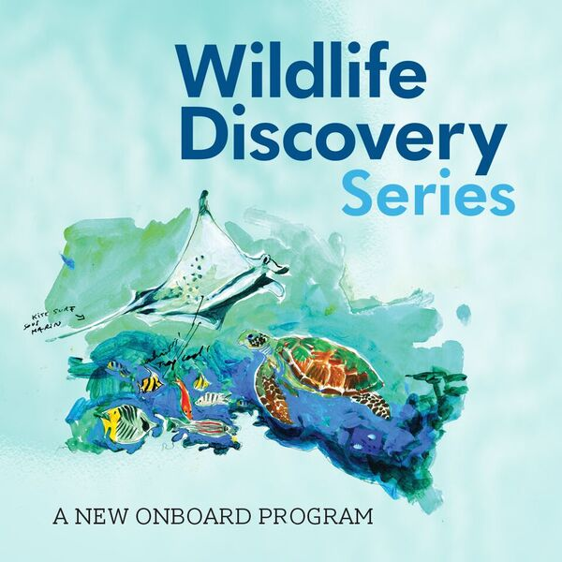

BELLEVUE, WASH. – February 15, 2018 – Paul Gauguin Cruises (www.pgcruises.com), operator of the highest-rated and longest continually sailing luxury cruise ship in the South Pacific, the m/s Paul Gauguin, is pleased to announce the line-up of Wildlife Discovery Series lecturers aboard 2018 voyages, as part of its partnership with the Wildlife Conservation Society (WCS).

WCS has been saving wildlife and wild places worldwide for over 120 years and aims to protect the world's largest wild places in 16 priority regions, home to more than 50 percent of the world's biodiversity, while ensuring a positive impact on millions of people. The Wildlife Discovery Series is an exciting program where guests of The Gauguin have the opportunity to learn about marine wildlife and habitats from some of the world’s most fascinating scientists and conservationists. For this series, lecturers will be sharing their research and expertise during presentations aboard select sailings.

Yashika Nand, Marine Scientist, WCS Fiji
February 24, 2018, Cook Islands & Society Islands
After working for the Department of Fisheries in Fiji as the lead coral researcher, Nand joined the WCS team in 2010 as a Marine Scientist. In that role, she manages all data from WCS’s biological monitoring program and helps integrate it into conservation planning in Fiji. Nand’s expertise includes coral health and disease assessments, including both coral and disease identification, experimental design, data analysis and statistical modeling, basic mapping, and the aquarium trade. She is currently pursuing a Master’s degree in coral reef ecology, focusing on coral disease, at the University of the South Pacific. Aboard The Gauguin, Nand will lecture on the conservation challenges and opportunities in the South Pacific and explore threats to coral reefs.

Ravaka Natacha Ranaivoson, Marine Conservation Director, WCS Madagascar Program
March 31, 2018, Tahiti & the Society Islands
Ranaivoson is in charge of WCS Madagascar’s strategic development, planning, budgeting, implementation, and monitoring. Her roles cover strategic program development, fundraising, the development of sustainable financing, and the identification and development of relevant partnerships for the program’s implementation and development. She supervises and gives support to the Madagascar scientific and field marine staff, oversees the program’s activities on the ground, and contributes to the communication and branding for the program. A trained economist, Ranaivoson has 16 years of experience in conservation finance, natural resources management, and community development in Africa, specifically Madagascar. She is among the African Conservation Champions selected by IUCN (International Union for Conservation of Nature) for the World Parks Congress. On The Gauguin, Ranaivoson will discuss the conservation of Madagascar’s marine biodiversity.

Ken Kassem, Marine Director, WCS Indonesia Program
May 5, 2018, Tahiti & the Society Islands
Kassem currently serves as the Marine Director for WCS’s Indonesia Program. His area of focus is the Coral Triangle, and he is passionate about making fisheries sustainable through community engagement. From 1997 to 2012, Kassem worked on tropical marine conservation projects around the world for the World Wildlife Fund, WCS, and the World Resources Institute, with extended stops in Washington DC, Fiji, and Malaysia. Prior to moving to Bogor, Indonesia to join WCS in 2016, he took a career break to focus on his PhD in fisheries management and policy at Kyoto University, Japan. Aboard The Gauguin, Kassem will share his expertise on marine conservation in the heart of the Coral Triangle: Indonesia.

Jason Patlis, Executive Director, WCS Marine Conservation
June 16, 2018, Tahiti & the Society Islands
Working internationally and domestically in public and private sectors, Patlis has 30 years of experience in nonprofit management, environmental law, public policy, and finance. He currently oversees WCS’s global marine conservation portfolio across 25 countries. Prior to joining WCS, Patlis served for nearly seven years as the President and CEO of the National Marine Sanctuary Foundation (NMSF), the nonprofit partner to the United States’ marine sanctuary system. Patlis also served as Vice President and Managing Director for US Government Relations at the World Wildlife Fund (WWF). He has specialized in natural resource governance, advancing laws and policies to manage natural resources and endangered species sustainably for the benefit of local communities and in the face of changing political systems. In the US, Patlis has worked on both sides of the Capitol, serving as Deputy Staff Director for the House Science Committee and as Majority Counsel on the Senate Environment and Public Works Committee. He also served for five years in NOAA’s Office of General Counsel handling issues relating to the Endangered Species Act. Overseas, Patlis worked as a legal expert in Indonesia to help shape new laws relating to forestry and coastal resource management as the country moved from dictatorship to democracy. His efforts helped pave the way for the establishment of Indonesia’s first national law on coastal management, enacted in 2007. He was a Fulbright Senior Scholar in 2000, and he is widely published in law and policy journals. Patlis received his JD from Cornell University School of Law and his BA from Haverford College. He will share his deep and wide-ranging expertise in all aspects of natural resource management during his presentations aboard The Gauguin.

Natalia A. Rossi, PhD, Cuba Country Manager, WCS Mesoamerica & Western Caribbean Program
October 6, 2018, Society Islands & Tahiti Iti
Rossi has worked with local governmental and non-governmental organizations to promote biodiversity conservation in Cuba, in the context of fast-evolving legislation. She became involved with coastal and crocodile conservation in Cuba in 2009, when she joined the late John Thorbjarnarson—WCS’s world-renowned herpetologist—in the development of projects and initiatives on the island. Since then, she has carried out conservation projects in Cuba in collaboration with WCS, Columbia University, the American Museum of Natural History, and several local stakeholders, leading numerous expeditions. Among the sites explored were the Zapata and Birama swamps in the southern Cuban archipelago and the Alejandro de Humboldt National Park. She has also facilitated expert workshops and other types of academic exchanges between the US and Cuba. Rossi obtained her B.S. in Ecology at the University of Buenos Aires, Argentina, and went on to work for five years on a binational sea turtle research and conservation project in Baja California Sur, Mexico. In 2007, she obtained a Fulbright Fellowship to pursue a Master’s degree in Conservation Biology at Columbia University. From there, she went on to work as Program Officer of WCS’s Latin America and Caribbean Program, where she helped to advance conservation activities in the region. Rossi recently finished her doctoral studies at Columbia University, with research focused on the integration of ecological and evolutionary approaches for the conservation of endangered crocodilians in Cuba and the wider Caribbean. Cuba’s wildlife and wild places are currently at a critical crossroads, and today Rossi leads the development of the WCS Cuba program to help strengthen Cuba’s protected areas management, conserve the country’s outstanding coral reefs, and promote sustainable fisheries. During lectures aboard The Gauguin, Rossi will discuss the biology and conservation of sea turtles.

Merry Camhi, Director, New York Seascape Program, WCS New York Aquarium and Global Marine Programs
December 15, 2018, Tahiti & the Society Islands
Camhi has been the Director of WCS’s New York Seascape Program, based at the New York Aquarium on Coney Island, since it was launched in July 2010 as the first WCS seascape in North America. This initiative seeks to raise public awareness and take action to conserve threatened marine wildlife in the busy waters of the New York Bight, using conservation, citizen science and education, and advocacy to improve management policies. Current New York Seascape projects include acoustic and satellite tagging of sharks to better understand their movements and habitat needs in the mid-Atlantic, tagging and restoration of American eels and alewife in New York’s tidal rivers, and diverse initiatives to build an active New York ocean constituency. Camhi has worked in marine conservation since receiving her PhD in Ecology from Rutgers University, where she studied sea turtles in Costa Rica and Georgia. She worked for ten years as senior scientist and then assistant director of Audubon’s Living Oceans Program, and as a consultant on a variety of marine and freshwater projects, including as Content Coordinator for the American Museum of Natural History’s exhibition Water: H20 = Life. Much of Camhi’s work is focused on domestic and international conservation and management of large ocean fishes, and particularly sharks. She co-authored the IUCN report The Conservation Status of Pelagic Sharks and Rays (2009) and co-edited the book Sharks of the Open Ocean (Wiley-Blackwell, 2008). Camhi will present a series of lectures on WCS’s marine conservation programs and efforts in the New York seascape aboard The Gauguin.

Paul Gauguin Cruises is proud to partner with WCS to offer this program on these select sailings in 2018. For additional information on WCS and the Wildlife Discovery Series, please visit www.pgcruises.com/WCS.

For more information about Paul Gauguin Cruises, please contact a Travel Professional, call 800-848-6172, or visit www.pgcruises.com.
###

About WCS (Wildlife Conservation Society)
MISSION: WCS saves wildlife and wild places worldwide through science, conservation action, education, and inspiring people to value nature. To achieve our mission, WCS, based at the Bronx Zoo, harnesses the power of its Global Conservation Program in nearly 60 nations and in all the world’s oceans and its five wildlife parks in New York City, visited by 4 million people annually. WCS combines its expertise in the field, zoos, and aquarium to achieve its conservation mission. Visit: newsroom.wcs.org. Follow: @WCSNewsroom. For more information: 347-840-1242.

About Paul Gauguin Cruises
Owned by Pacific Beachcomber S.C., French Polynesia’s leading luxury hotel and cruise operator, Paul Gauguin Cruises operates the 5+-star cruise ship, the 332-guest m/s Paul Gauguin, providing a deluxe cruise experience tailored to the unparalleled wonders of Tahiti, French Polynesia, and the South Pacific. Paul Gauguin Cruises has been recognized by notable publications in travel and lifestyle and was voted “#1 Midsize-Ship Ocean Cruise Line” by readers in the Travel + Leisure World’s Best Awards 2017†. The line was also recognized as one of the “Top Small Cruise Lines” in the Condé Nast Traveler 2017 Readers’ Choice Awards and is honored on the publication’s 2018 “Gold List.” Paul Gauguin Cruises was also selected as “Best Small-Ship Cruise Line” in Global Traveler’s Leisure Lifestyle Awards in 2016 and 2017, and received top honors as the “#1 Cruise Line for Honeymooners” in BRIDES Magazine’s 2017 Honeymoon Awards.

Media Contact:
Vanessa Bloy
Paul Gauguin Cruises
Director of Public Relations
(425) 440-6255
vbloy@pgcruises.com

†From Travel + Leisure Magazine, August 2017 © Time Inc. Affluent Media Group. Used under license. Travel + Leisure and Time Inc. Affluent Media Group are not affiliated with, and do not endorse products or services of, Paul Gauguin Cruises.

