PAUL GAUGUIN CRUISES ANNOUNCES 2021 VOYAGES IN TAHITI, FRENCH POLYNESIA & THE SOUTH PACIFIC
NEW 11-NIGHT TUAMOTUS & SOCIETY ISLANDS ITINERARY AND A RETURN TO FIJI

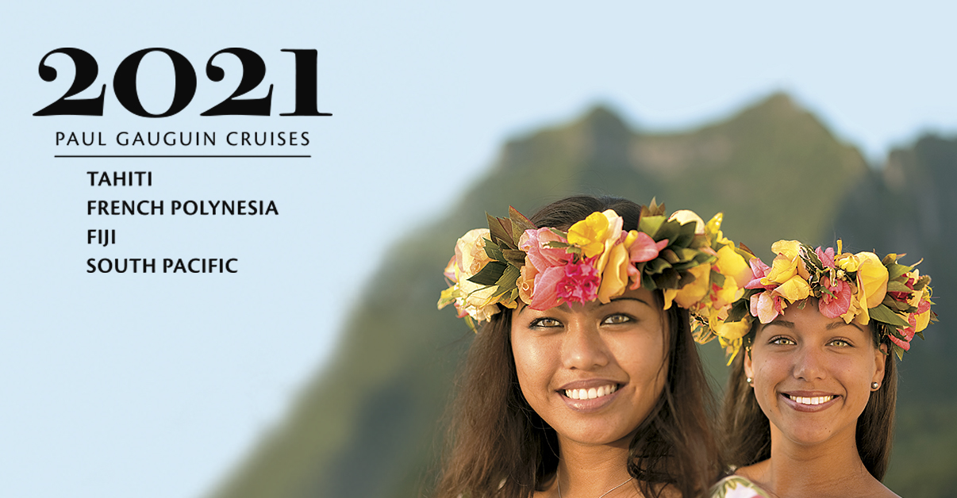

BELLEVUE, WASH. – October 21, 2019 – Paul Gauguin Cruises (www.pgcruises.com), operator of the highest-rated and longest continually sailing luxury cruise ship in the South Pacific, the m/s Paul Gauguin, is pleased to officially announce its 2021 voyages, which feature popular favorites along with a new 11-night Tuamotus & Society Islands itinerary and 12- and 13-night Fiji, Tonga, Cook & Society Islands sailings.

The new 11-night Tuamotus & Society Islands itinerary features two visits to Paul Gauguin Cruises’ renowned private island Motu Mahana, where guests can enjoy a day of watersports, Polynesian activities, a sumptuous barbecue feast, and cocktails from full and floating bars. Voyages depart Papeete, Tahiti, on January 23, 2021, and December 4, 2021, and sail to Huahine, Society Islands; Taha’a (Motu Mahana), Society Islands; Bora Bora, Society Islands (overnight); At Sea; Rangiroa, Tuamotus; Fakarava, Tuamotus; At Sea; Taha’a (Motu Mahana); Moorea, Society Islands; and Papeete, Tahiti.

In 2021, The Gauguin returns to the tropical wonderland of Fiji on two voyages that also feature Tonga, the Cook Islands, and the Society Islands. The 13-night voyage departs Papeete, Tahiti, on May 22, 2021, and visits: Moorea, Society Islands; Taha’a (Motu Mahana), Society Islands; Bora Bora, Society Islands; At Sea; Aitutaki, Cook Islands; At Sea (2 days); Vava’u, Tonga; At Sea; Savusavu, Vanua Levu, Fiji; Suva, Viti Levu, Fiji; Beqa Island, Fiji; and Lautoka, Viti Levu, Fiji. The 12-night reverse itinerary departs June 5, 2021, and calls at the same ports except Beqa Island, Fiji.

The Gauguin will also be showcasing its most sought-after itineraries: the 7-night Tahiti & the Society Islands; the 7-night Society Islands & Tahiti Iti; the 10-night Society Islands & Tuamotus; the 11-night Cook Islands & Society Islands; and the 14-night Marquesas, Tuamotus & Society Islands.

Designed specifically to sail the pristine lagoons of these islands, The Gauguin provides an up-close, authentic experience of the South Seas and offers an elegant yet casual ambiance with luxurious accommodations, exceptional service, gourmet dining, trademark Polynesian hospitality, private beach retreats, and extraordinary all-inclusive value.

To launch its 2021 voyages, Paul Gauguin Cruises is offering savings of 50% off standard cruise fares on all voyages, plus included airfare from Los Angeles. Past guests of Paul Gauguin Cruises enjoy additional savings of up to 15% off final cruise fares on select sailings as members of the Paul Gauguin Society.

For rates or more information on Paul Gauguin Cruises, please contact a Travel Professional, call 800-848-6172, or visit www.pgcruises.com.
###
About Paul Gauguin Cruises
Paul Gauguin Cruises operates the 5+-star cruise ship, the 332-guest m/s Paul Gauguin, providing a deluxe cruise experience tailored to the unparalleled wonders of Tahiti, French Polynesia, and the South Pacific. Paul Gauguin Cruises has been recognized by notable publications in travel and lifestyle and was voted “#1 Midsize-Ship Ocean Cruise Line” by readers in the Travel + Leisure World’s Best Awards 2019. The line was recognized as one of the “Top Small Cruise Lines” in the Condé Nast Traveler 2019 Readers’ Choice Awards and is honored on the publication’s 2018 “Gold List.” Paul Gauguin Cruises was selected as “Best Small-Ship Cruise Line” in Global Traveler’s Leisure Lifestyle Awards from 2016 to 2019, and has received top honors in BRIDES Magazine’s Honeymoon Awards for the past three years. And recently the line was recognized for the third time for having the “Best French Polynesia Cruises” in the AFAR Travelers’ Choice Awards. In September 2019, Paul Gauguin Cruises joined PONANT’s family, the world leader of small ship cruising.
Media Contact:
Paul Gauguin Cruises
Vanessa Bloy, Director of Public Relations
(425) 440-6255/vbloy@pgcruises.com

*From Travel + Leisure Magazine, August 2019 © Time Inc. Affluent Media Group. Used under license. Travel + Leisure and Time Inc. Affluent Media Group are not affiliated with, and do not endorse products or services of, Paul Gauguin Cruises.

