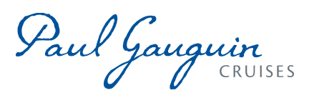
PAUL GAUGUIN CRUISES ANNOUNCES 2022 VOYAGES IN TAHITI, FRENCH POLYNESIA,
FIJI & THE SOUTH PACIFIC

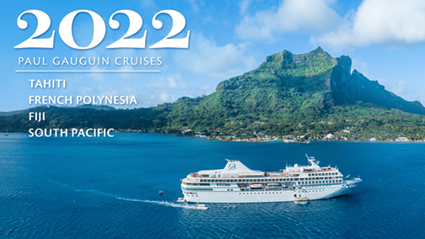

BELLEVUE, WASH. – January 27, 2021 – Paul Gauguin Cruises (www.pgcruises.com), operator of the highest-rated and longest continually sailing luxury cruise ship in the South Pacific, the m/s Paul Gauguin, announces its new 2022 schedule featuring Tahiti, French Polynesia, Fiji, and South Pacific itineraries.

The Gauguin will be showcasing its most sought-after itineraries in 2022: the 7-night Tahiti & the Society Islands, 10-night Society Islands & Tuamotus, 11-night Cook Islands & Society Islands, and 14-night Marquesas, Tuamotus & Society Islands.
The Gauguin will also be returning to Fiji in 2022, offering 12-night and 13-night Fiji, Tonga, Cook & Society Islands itineraries. These comprehensive voyages follow in the wake of explorers, encompassing the exquisite Society Islands, home waters of The Gauguin, and the Cook Islands with its unique culture and exquisite lagoons. Other highlights include sailing across the International Date Line, a rare visit to the Kingdom of Tonga, and the paradisiacal Fijian islands. Ports of call on the voyages are Papeete, Tahiti; Moorea, Society Islands; Taha’a (Motu Mahana), Society Islands; Bora Bora, Society Islands; Aitutaki, Cook Islands; Vava’u, Tonga; Savusavu, Vanua Levu, Fiji; Suva, Viti Levu, Fiji; Beqa Island, Fiji (13-night sailing only); and Lautoka, Viti Levu, Fiji.
Designed specifically to sail the pristine lagoons of these islands, The Gauguin provides an up-close, authentic experience of the South Seas and offers an elegant yet casual ambiance with luxurious accommodations, exceptional service, gourmet dining, trademark Polynesian hospitality, private beach retreats, and extraordinary all-inclusive value.

To launch its 2022 voyages, Paul Gauguin Cruises is offering savings of 30% off standard cruise fares on all voyages, plus included airfare from Los Angeles.

Paul Gauguin Cruises’ top priority has always been to ensure the safety and comfort of its passengers. The health protocols developed by Paul Gauguin Cruises and PONANT exceeds international regulations. The Sail with Confidence booking policy is an extra effort to ensure travelers feel confident booking a well-deserved cruise vacation now without worry should they need to cancel.

For rates or more information on Paul Gauguin Cruises, please contact a Travel Professional, call 800-848-6172, or visit www.pgcruises.com.
###
About Paul Gauguin Cruises
Paul Gauguin Cruises operates the 5+-star cruise ship, the 332-guest m/s Paul Gauguin, providing a deluxe cruise experience tailored to the unparalleled wonders of Tahiti, French Polynesia, and the South Pacific. Paul Gauguin Cruises has been recognized by notable publications in travel and lifestyle. One of the “Top Small Cruise Lines” in the Condé Nast Traveler 2020 Readers’ Choice Awards and is honored on the publication’s 2020 “Gold List.” Paul Gauguin Cruises was selected as “Best Small-Ship Cruise Line” in Global Traveler’s Leisure Lifestyle Awards from 2016 to 2020, and has received top honors in BRIDES Magazine’s Honeymoon Awards for the past three years. And recently the line was recognized for the fourth time for having the “Best French Polynesia Cruises” in the AFAR Travelers’ Choice Awards. In September 2019, Paul Gauguin Cruises joined PONANT’s family, the world leader of small-ship cruising.

Media Contact:
Paul Gauguin Cruises
Public Relations Department
mediarelations@pgcruises.com

