PAUL GAUGUIN CRUISES LAUNCHES A “BEST OFFER, EVER” SPRING BONUS
$500 Per-Stateroom Shipboard Credit Plus Reduced Deposit on 2016 and 2017 Voyages

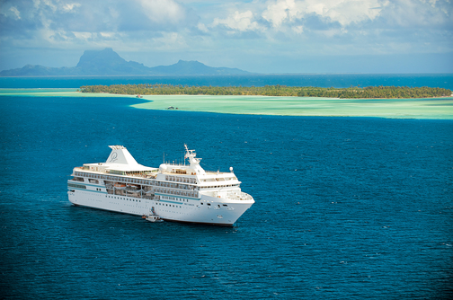

BELLEVUE, WASH. – March 15, 2016 – Paul Gauguin Cruises (www.pgcruises.com), operator of the highest-rated and longest continually sailing luxury cruise ship in the South Pacific, the m/s Paul Gauguin, is offering a spring bonus of $500 per-stateroom Shipboard Credit on any 2016 or 2017 voyage aboard The Gauguin in Tahiti, French Polynesia, and the South Pacific when reserved by April 30, 2016. As an additional bonus, deposits have been reduced to $250 per person.*

The $500 per-stateroom Shipboard Credit can be used to indulge in a spa treatment in Deep Nature Spa, purchase a souvenir in La Boutique, or book a shore excursion aboard The Gauguin.

This bonus is in addition to the line’s current offer of savings of 50% off standard all-inclusive cruise fares on all voyages, plus included roundtrip airfare from Los Angeles on The Gauguin itineraries.

For additional information on Paul Gauguin Cruises, please contact a Travel Professional, call 800-848-6172, or visit www.pgcruises.com.
###
About Paul Gauguin Cruises
Owned by Pacific Beachcomber S.C., French Polynesia’s leading luxury hotel and cruise operator, Paul Gauguin Cruises operates the 5+-star cruise ship, the 332-guest m/s Paul Gauguin, providing a deluxe cruise experience tailored to the unparalleled wonders of Tahiti, French Polynesia, and the South Pacific. Paul Gauguin Cruises accolades include being voted #2 in the category of “Top Small Cruise Lines” in the Condé Nast Traveler 2015 Readers’ Choice Awards. In addition, the line was voted by Travel + Leisure readers “#1 Small-Ship Cruise Line” and “#1 Small-Ship Cruise Line for Families” in the Travel + Leisure 2014 World’s Best Awards. Recently, readers voted Paul Gauguin Cruises “#2 Small-Ship Ocean Cruise Line” in the Travel + Leisure 2015 World’s Best Awards.†
Media Contact:
Paul Gauguin Cruises
Vanessa Bloy, Director of Public Relations
(425) 440-6255
vbloy@pgcruises.com

*New bookings only. Offer may be combined with FREE 3rd guest in stateroom offer on 2016 sailings and applicable past guest savings but may not be combinable with other offers. Port, security, and handling charges are $119-$260 additional. $250 reduced-rate deposit per person is refundable, except for a $100 per-person administration fee. Shipboard Credits are per stateroom regardless of occupancy. Must book by April 30, 2016. Call for details.

†From Travel + Leisure Magazine, August 2015 ©2015 Time Inc. Affluent Media. Used under license. Travel + Leisure and Time Inc. Affluent Media are not affiliated with, and do not endorse products or services of Paul Gauguin Cruises.

