PAUL GAUGUIN CRUISES ANNOUNCES “TAHITI FOR THE HOLIDAYS”
SPECIAL OFFER AND REDUCED DEPOSIT

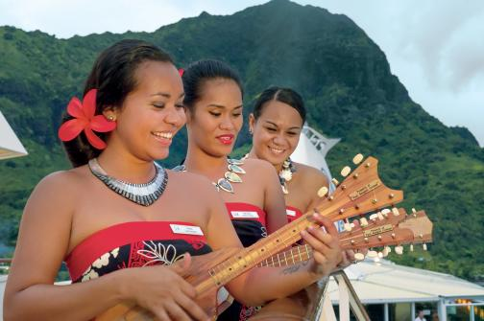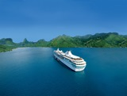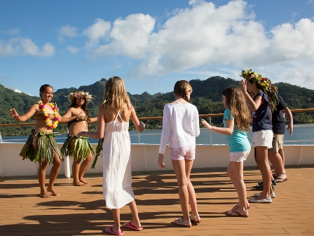

BELLEVUE, WASH. – June 3, 2019 – Paul Gauguin Cruises (www.pgcruises.com), operator of the highest-rated and longest continually sailing luxury cruise ship in the South Pacific, the m/s Paul Gauguin, features two 7-night Tahiti & the Society Islands voyages on The Gauguin offering the perfect way to celebrate the holidays in tropical paradise.

During its “Tahiti for the Holidays” promotion, Paul Gauguin Cruises is offering savings of up to $1,900*per person off
7-night Tahiti & the Society Islands December holiday voyages aboard The Gauguin when booked between June 3 and 15, 2019. The savings are on top of 50% off brochure fares and include roundtrip airfare from Los Angeles or San Francisco. As a special holiday bonus, deposits are also reduced to $250 per person. A special single traveler offer is also available.

On The Gauguin’s December 21, 2019, voyage, guests can enjoy the Christmas holiday basking in the warmth of French Polynesia’s white-sand beaches with cruise fares now from $4,995 per person, based on double occupancy. Or ring in the New Year on the South Seas in festive style during the December 28, 2019, voyage with special cruise fares starting from $7,045 per person (balcony cabin), based on double occupancy.

The 7-night Tahiti & the Society Islands holiday cruises depart Papeete, Tahiti, and sail to Huahine, Taha’a (Motu Mahana), Bora Bora (overnight), and Moorea (overnight) in the Society Islands. In addition to cruising to beautiful islands in French Polynesia and highlighting Polynesian culture, these voyages feature complimentary access to Paul Gauguin Cruises’ two exclusive retreats—Motu Mahana, an islet off the coast of Taha’a, and a private beach in Bora Bora. At Motu Mahana, guests enjoy a day of watersports, Polynesian activities, a barbecue feast, and cocktails from full-service and floating bars. In Bora Bora, guests can relax on a white-sand beach and enjoy refreshments, a game of volleyball, and snorkeling in crystal-clear waters.
On both holiday sailings, Paul Gauguin Cruises is also offering the Moana Explorer program in partnership with Te mana o te moana, a South Pacific marine education and conservation foundation. The Moana Explorer program invites children and teens, ages 7-15, to discover and value the natural wonders of the South Pacific through hands-on, interactive learning on board and ashore. Every day of the voyage, there is a combination of naturalist-led island and/or beach excursions, science activities, crafts, games, and other adventures. Depending on the itinerary, children and teens might explore underwater life, conduct water experiments, create natural jewelry, go on a treasure hunt, learn about Tahitian culture, discover island legends and geology, design a Polynesian tattoo, and more.

For more information on Paul Gauguin Cruises, contact a Travel Professional, call 800-848-6172, or visit www.pgcruises.com.
###
About Paul Gauguin Cruises
Owned by Pacific Beachcomber S.C., French Polynesia’s leading luxury hotel and cruise operator, Paul Gauguin Cruises operates the 5+-star cruise ship, the 332-guest m/s Paul Gauguin, providing a deluxe cruise experience tailored to the unparalleled wonders of Tahiti, French Polynesia, and the South Pacific. Paul Gauguin Cruises has been recognized by notable publications in travel and lifestyle and was voted “#2 Midsize-Ship Ocean Cruise Line” by readers in the Travel + Leisure World’s Best Awards 2018†. The line was also recognized as one of the “Top Small Cruise Lines” in the Condé Nast Traveler 2018 Readers’ Choice Awards and is honored on the publication’s 2018 “Gold List.” Paul Gauguin Cruises was also selected as “Best Small-Ship Cruise Line” in Global Traveler’s Leisure Lifestyle Awards from 2016 to 2019, and has received top honors in BRIDES Magazine’s Honeymoon Awards for the past three years.

Media Contact:
Vanessa Bloy
Paul Gauguin Cruises
Director of Public Relations
(425) 440-6255
vbloy@pgcruises.com

*All fares are in US dollars, per person, based on double occupancy, and reflect promotional savings, are for new bookings only, are subject to availability, and must be booked by June 15, 2019. Roundtrip airfare from Los Angeles or San Francisco is based on availability in class of service. Offer may be combined with applicable 3rd guest in stateroom offer but may not be combined with other offers. Port, security, and handling charges of $149 per person are additional. Additional terms and conditions may apply. Call for details. For full terms and conditions, visit www.pgcruises.com.

†From Travel + Leisure Magazine, August 2018 © Time Inc. Affluent Media Group. Used under license.Travel + Leisure and Time Inc. Affluent Media Group are not affiliated with, and do not endorse products or services of, Paul Gauguin Cruises.

