PAUL GAUGUIN CRUISES ANNOUNCES LINE-UP OF WILDLIFE DISCOVERY SERIES LECTURERS

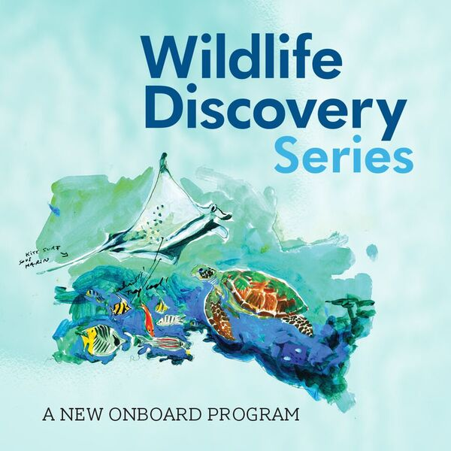

BELLEVUE, WASH. – October 26, 2016 – Paul Gauguin Cruises (www.pgcruises.com), operator of the highest-rated and longest continually sailing luxury cruise ship in the South Pacific, the m/s Paul Gauguin, is pleased to announce the line-up of Wildlife Discovery Series lecturers aboard 2017 voyages, as part of its partnership with the Wildlife Conservation Society (WCS).

WCS has been saving wildlife and wild places worldwide for over 120 years and aims to protect half of the planet’s biodiversity, while ensuring a positive impact on millions of people. The Wildlife Discovery Series is an exciting new program where guests of The Gauguin have the opportunity to learn about marine wildlife and habitats from some of the world’s most fascinating scientists, oceanographers, and conservationists. For this series, lecturers will be sharing their research and expertise during presentations aboard select sailings.

Katherine Holmes, Associate Director, WCS Global Marine Programs
February 18, 2017, Tahiti & the Society Islands
From WCS headquarters in New York, Holmes supervises conservation programs across the Caribbean, North America, Latin America, and Western Africa. With extensive experience in Melanesia and the South Pacific, Holmes has previously served as the WCS Marine Director in Papua New Guinea. She is knowledgeable about marine area management, coral reef ecology, and sea turtle biology. Holmes is also adept at biocultural conservation, and has developed community-based initiatives and educational tools that blend traditional and modern approaches. Throughout her career, she has studied sea turtle populations, helped to establish marine reserves, and surveyed coastal habitats to inform conservation planning. Holmes has participated in marine science research in the Bahamas, Barbados, Belize, Nicaragua, Ecuador, Myanmar, Indonesia, and the Philippines.

Emily Darling, PhD, Associate Scientist, WCS Global Marine Programs
June 7, 2017, Bali to Fiji
As an Associate Conservation Scientist for WCS global marine programs, Dr. Darling helps to save wildlife and wild places, and inspires people to value nature in oceans and seascapes worldwide. She is a dedicated coral reef ecologist, passionate about sustaining tropical corals in a changing climate. In her present role at WCS, Dr. Darling coordinates a coral reef monitoring program across Melanesia, Indonesia, the Caribbean, and Western Indian Ocean. Her research focuses on fisheries management, community ecology, and coral responses to climate change. In addition to publishing in scientific journals, Dr. Darling has contributed to popular science blogs for major media networks.

Sangeeta Mangabhai, PhD, Director, WCS Fiji
June 7, 2017, Bali to Fiji
Dr. Mangabhai is currently based in Suva, Fiji, and has worked for WCS since 2014. She has empowered local communities to make informed decisions about their natural resources. Dr. Mangabhai specializes in designing marine protected areas, assessing coral reef resilience, monitoring fisheries, and evaluating the return on investment of conservation action. Throughout her career, she has studied ecology and advised policy in Fiji, Vanuatu, Kiribati, Cook Islands, Solomon Islands, Papua New Guinea, Australia, Indonesia, and East Africa. Dr. Mangabhai has served as an adjunct scientist for the New England Aquarium, editor for Pacific Conservation Biology, and committee member for the Women in Fisheries Network.

Tim McClanahan, PhD, Senior Zoologist, WCS Kenya
August 12, 2017, Tahiti & the Society Islands
Dr. McClanahan specializes in coral reef ecology. He studies the links between coral reef ecosystems and the humans who depend on them, integrating marine biology with cultural psychology to achieve social-ecological conservation outcomes. Dr. McClanahan has published an impressive archive of journal articles, book chapters, and reviews to inform science worldwide. His research explores the benefits of marine protected areas and fisheries management on ocean diversity and sustainability, as well as the impacts of overfishing, pollution, and climate change on coral reefs.

Nyawira Muthiga, PhD, Marine Director, WCS Kenya
August 12, 2017, Tahiti & the Society Islands
Dr. Muthiga has dedicated her career to protecting East African marine ecosystems, managing projects in Kenya, Tanzania, Madagascar, Mauritius, and the Seychelles. Her conservation has focused on coastal areas, wetlands, coral reefs, and sustainable fisheries. Dr. Muthiga has also created community eco-tourism initiatives, as well as training programs to develop the next generation of East African scientists. She has been actively involved in the Western Indian Ocean Marine Science Association, the Western Indian Ocean Consortium, the Coral Reef Task Force, and the Kenya Sea Turtle Conservation Committee. Dr. Muthiga has been internationally recognized for her leadership, receiving awards from the Kenyan president, the National Geographic Society, and the Howard G. Buffet Foundation.

Alexander Tewfik, PhD, Conservation Scientist, WCS Belize
October 7, 2017, Cook Islands & Society Islands
Dr. Tewfik is currently based at the Glover’s Reef Research Station and South Water Caye Marine Reserve, and has previously lived in the Caribbean, Bahamas, Asia-Pacific, and United States. His expertise includes marine protected areas, sustainable fisheries, community-based conservation, and livelihood diversification. He has studied conch and lobster invertebrates, and has developed best practices for recovering coral reefs, sandy beaches, and seagrass habitats.

Stacy Jupiter, PhD, Director, WCS Melanesia
November 11, 2017, Tahiti & the Society Islands
Dr. Jupiter and her team collaborate with local communities and governments to protect the region’s biodiversity, along with the livelihoods and well-being of the people. In 2015, she received the Early Career Conservationist Award in recognition of her holistic approach to integrate local knowledge and traditional beliefs into conservation action and natural resource management. Dr. Jupiter’s expertise includes designing marine protected areas, recovering coral reefs, and land-sea spatial planning. Her research has focused on human impacts to tropical habitats and ecosystem services, and she has authored several guides for conservation best practices in the Pacific islands.

Martin Robards, PhD, Director, WCS Arctic Beringia
December 23, 2017, Tahiti & the Society Islands
Dr. Robards manages a trans-boundary conservation program that comprises Alaska, the Inuvialuit Settlement Region in northwestern Canada, and the Chukotka Peninsula in northeastern Russia. In this role, he collaborates with indigenous hunters in Arctic communities, as well as policy makers in Washington D.C., to protect marine mammals, shorebirds, and other threatened species in remote northern habitats. Dr. Robards is an expert in the ecological, social, and economic conditions of the Arctic. He has studied the impacts of energy development, commercial shipping, and climate change, and has helped to develop environmental policy.

Paul Gauguin Cruises is proud to partner with WCS to offer this program on these select sailings in 2017. For additional information on the Wildlife Discovery Series, please visit www.pgcruises.com/WCS.

For more information about Paul Gauguin Cruises, please contact a Travel Professional, call 800-848-6172, or visit www.pgcruises.com.
###

About Paul Gauguin Cruises
Owned by Pacific Beachcomber S.C., French Polynesia’s leading luxury hotel and cruise operator, Paul Gauguin Cruises operates the 5+-star cruise ship, the 332-guest m/s Paul Gauguin, providing a deluxe cruise experience tailored to the unparalleled wonders of Tahiti, French Polynesia, Fiji, and the South Pacific. Paul Gauguin Cruises accolades include being voted #2 in the category of “Top Small Cruise Lines” in the Condé Nast Traveler 2015 Readers’ Choice Awards and recognition on the publication’s 2016 “Gold List.” In addition, the line was voted by Travel + Leisure readers “#1 Small-Ship Cruise Line” and “#1 Small-Ship Cruise Line for Families” in the Travel + Leisure 2014 World’s Best Awards. Recently, readers voted Paul Gauguin Cruises “#1 Midsize-Ship Ocean Cruise Line” in the Travel + Leisure World’s Best Awards 2016.†
Media Contact:
Paul Gauguin Cruises
Vanessa Bloy, Director of Public Relations
(425) 440-6255
vbloy@pgcruises.com

†From Travel + Leisure, August 2016 ©2016 Time Inc. Affluent Media Group. Used under license. Travel + Leisure and Time Inc. Affluent Media Group are not affiliated with, and do not endorse products or services of Paul Gauguin Cruises.

