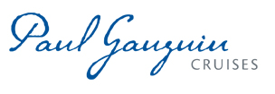
PAUL GAUGUIN CRUISES ANNOUNCES A “BEST GIFT, EVER” HOLIDAY BONUS OFFER
Up to $400 Shipboard Credit on Balcony Staterooms Plus Reduced Deposit on Select Voyages

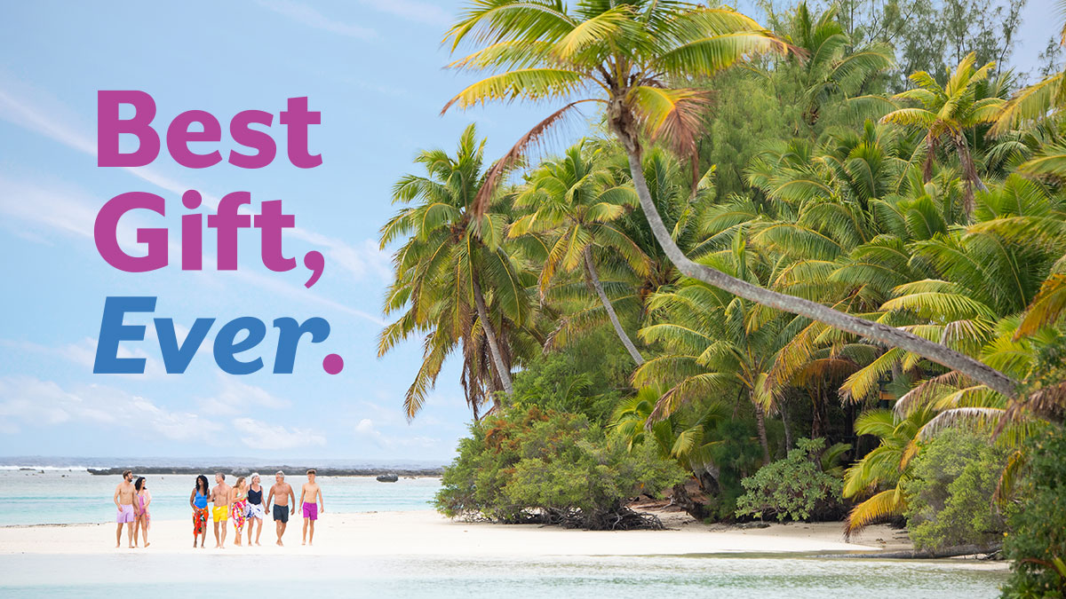

BELLEVUE, WASH. – December 2, 2019 – Paul Gauguin Cruises (www.pgcruises.com), operator of the highest-rated and longest continually sailing luxury cruise ship in the South Pacific, the m/s Paul Gauguin, is offering a holiday bonus of up to $400 Shipboard Credit on balcony staterooms on select 2020 and 2021 voyages when booked by December 31, 2019. As an additional holiday gift, deposits on those sailings have been reduced to $250 per person.

Shipboard Credit can be used to indulge in a spa treatment in Deep Nature Spa, purchase a souvenir in La Boutique, book a shore excursion aboard The Gauguin, and more. Shipboard Credit varies by balcony stateroom category:
- $250 Shipboard Credit per balcony stateroom, categories C and D on select sailings
- $400 Shipboard Credit per balcony stateroom, categories B and above on select sailings

Additionally, Paul Gauguin Cruises is offering savings of 50% off standard all-inclusive cruise fares on all voyages, plus included airfare from Los Angeles.

For additional information on Paul Gauguin Cruises, please contact a Travel Advisor, call 800-848-6172, or visit www.pgcruises.com.

New bookings only. Offer may be combined with applicable 3rd guest in stateroom offer and applicable past guest savings but may not be combinable with other offers. Port, security, and handling charges are $159-$305 additional. Reduced-rate deposit of $250 per person is refundable less a $100 administration fee. Solo travelers who pay the full supplement receive 100% of the Shipboard Credit for their stateroom category; all others receive 50% of the value per stateroom. Shipboard Credit amount is determined by balcony stateroom category. Shipboard Credits used for shore excursions must be booked on board at time of sailing. Offer ends December 31, 2019. Voyages excluded from this promotion are the March 28; April 11; June 17; and August 29, 2020, sailings. Call for details.
###

About Paul Gauguin Cruises
Paul Gauguin Cruises operates the 5+-star cruise ship, the 332-guest m/s Paul Gauguin, providing a deluxe cruise experience tailored to the unparalleled wonders of Tahiti, French Polynesia, and the South Pacific. Paul Gauguin Cruises has been recognized by notable publications in travel and lifestyle and was voted “#1 Midsize-Ship Ocean Cruise Line” by readers in the Travel + Leisure World’s Best Awards 2019. The line was recognized as one of the “Top Small Cruise Lines” in the Condé Nast Traveler 2019 Readers’ Choice Awards and is honored on the publication’s 2018 “Gold List.” Paul Gauguin Cruises was selected as “Best Small-Ship Cruise Line” in Global Traveler’s Leisure Lifestyle Awards from 2016 to 2019, and has received top honors in BRIDES Magazine’s Honeymoon Awards for the past three years. And recently the line was recognized for the third time for having the “Best French Polynesia Cruises” in the AFAR Travelers’ Choice Awards. In September 2019, Paul Gauguin Cruises joined PONANT’s family, the world leader of small ship cruising.

Media Contact:
Vanessa Bloy
Paul Gauguin Cruises
Director of Public Relations
(425) 440-6255
vbloy@pgcruises.com

†From Travel + Leisure Magazine, August 2019 © Time Inc. Affluent Media Group. Used under license. Travel + Leisure and Time Inc. Affluent Media Group are not affiliated with, and do not endorse products or services of, Paul Gauguin Cruises.

