PAUL GAUGUIN CRUISES AWARDED BEST SMALL-SHIP CRUISE LINE BY GLOBAL TRAVELER MAGAZINE

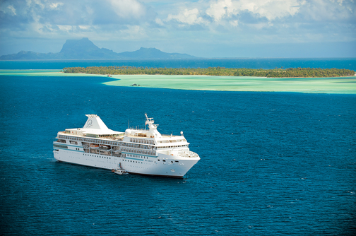

BELLEVUE, WASH. – May 20, 2016 – Paul Gauguin Cruises (www.pgcruises.com), operator of the highest-rated and longest continually sailing luxury cruise ship in the South Pacific, the m/s Paul Gauguin, received the award for “Best Small-Ship Cruise Line” during Global Traveler’s 4th Annual Leisure Lifestyle Awards ceremony on May 19, 2016, at the Sofitel Los Angeles at Beverly Hills.

Global Traveler is a monthly magazine written exclusively for frequent business and luxury travelers. Awards were given to the best leisure destinations, airlines, cruise lines, hotels, and tour operators voted by Global Traveler and its readers. The entire list of winners will be announced in the Leisure Lifestyle edition of Global Traveler available in May 2016 and online at www.globaltravelerusa.com.

“We are thrilled to be voted ‘Best Small-Ship Cruise Line,’” remarked Alicia Cummings, Vice President of Marketing for Paul Gauguin Cruises, who accepted the award at the ceremony. “Thank you to Global Traveler and its readers for this prestigious honor. It’s a testament to our dedicated staff, who delivers extraordinary service aboard our voyages in Tahiti, French Polynesia, Fiji, and the South Pacific.”

Paul Gauguin Cruises was also recently voted #2 in the category of “Top Small Cruise Lines” in the Condé Nast Traveler 2015 Readers’ Choice Awards and recognized on the publication’s 2016 “Gold List.” In addition, the line was voted “#1 Small-Ship Cruise Line” and “#1 Small-Ship Cruise Line for Families” by readers in Travel + Leisure’s 2014 World’s Best Awards. Readers also voted Paul Gauguin Cruises as the “#2 Small-Ship Ocean Cruise Line” in the Travel + Leisure 2015 World’s Best Awards.†

For more information about Paul Gauguin Cruises, please contact a Travel Professional, call 800-848-6172, or visit www.pgcruises.com.
###
About Paul Gauguin Cruises
Owned by Pacific Beachcomber S.C., French Polynesia’s leading luxury hotel and cruise operator, Paul Gauguin Cruises operates the 5+-star cruise ship, the 332-guest m/s Paul Gauguin, providing a deluxe cruise experience tailored to the unparalleled wonders of Tahiti, French Polynesia, Fiji, and the South Pacific.
Media Contact:
Paul Gauguin Cruises
Vanessa Bloy, Director of Public Relations
(425) 440-6255
vbloy@pgcruises.com

†From Travel + Leisure Magazine, August 2015 ©2015 Time Inc. Affluent Media. Used under license. Travel + Leisure and Time Inc. Affluent Media are not affiliated with, and do not endorse products or services of Paul Gauguin Cruises.

