PAUL GAUGUIN CRUISES AWARDED BEST SMALL-SHIP CRUISE LINE
BY GLOBAL TRAVELER MAGAZINE FOR THE SECOND CONSECUTIVE YEAR

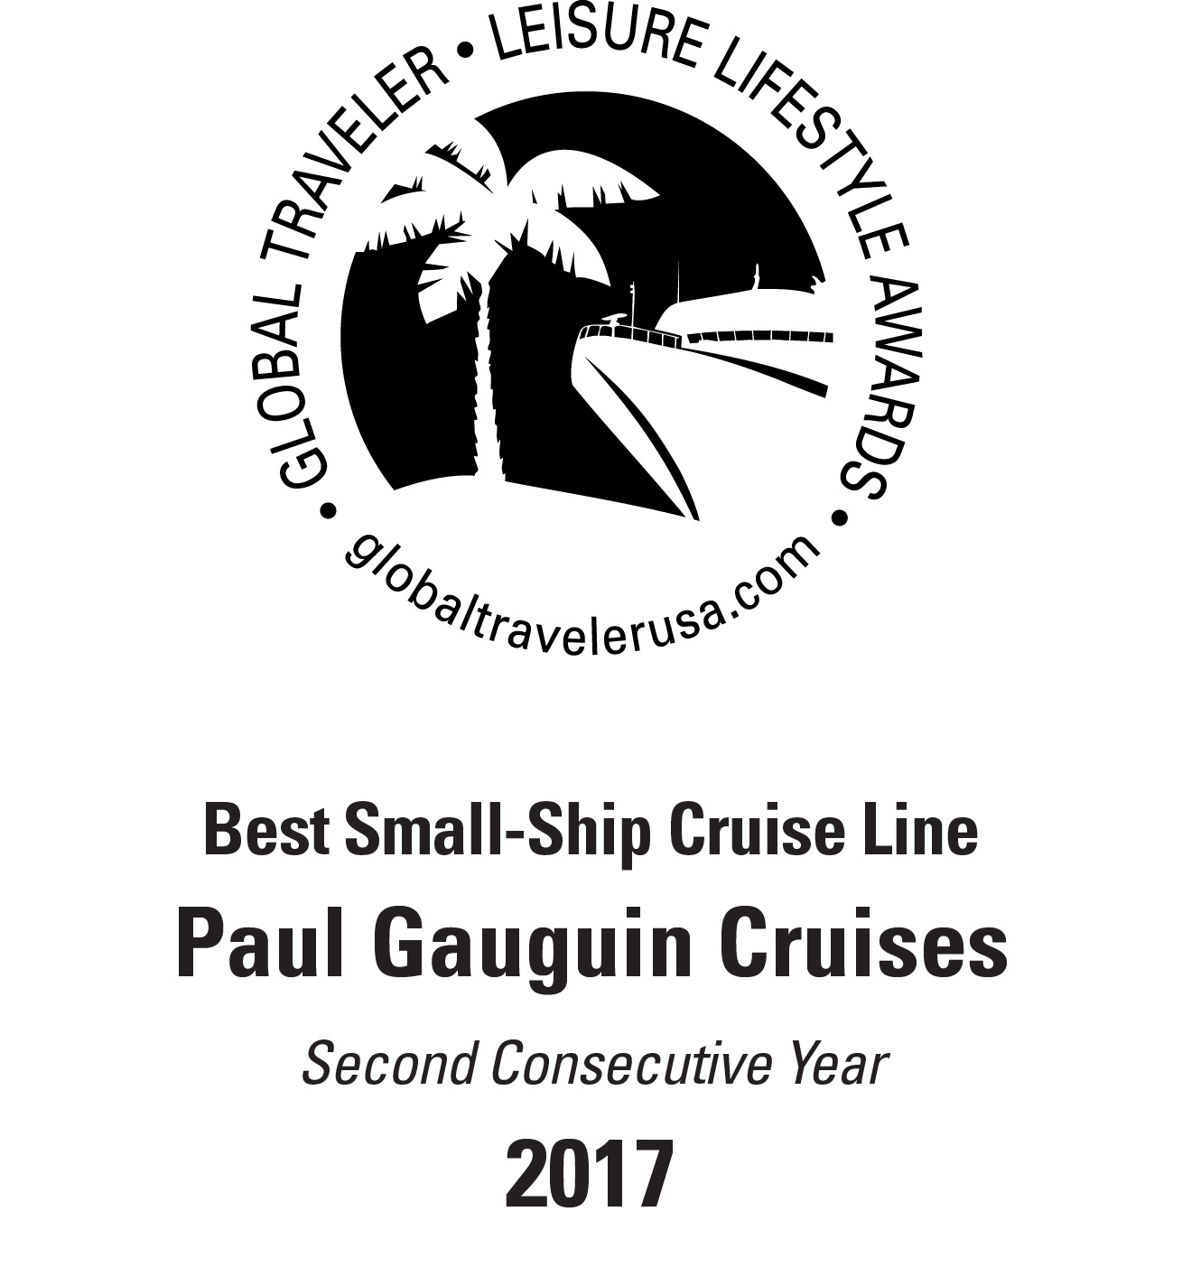
BELLEVUE, WASH. – May 19, 2017 – Paul Gauguin Cruises (www.pgcruises.com), operator of the highest-rated and longest continually sailing luxury cruise ship in the South Pacific, the m/s Paul Gauguin, received the award for “Best Small-Ship Cruise Line” for the second consecutive year during Global Traveler’s 5th Annual Leisure Lifestyle Awards ceremony on May 18, 2017, at the Sofitel Los Angeles at Beverly Hills.

Global Traveler is a monthly magazine written exclusively for frequent business and luxury travelers. Awards were given to the best leisure destinations, airlines, cruise lines, hotels, and tour operators voted by Global Traveler and its readers.

“We are thrilled to be voted ‘Best Small-Ship Cruise Line,’” remarked Diane Moore, President of Paul Gauguin Cruises, who accepted the award at the ceremony. “Thank you to Global Traveler and its readers for this prestigious honor. It’s a testament to our dedicated staff, who delivers extraordinary service aboard our voyages in Tahiti, French Polynesia, Fiji, and the South Pacific.”

The winners are listed in the Leisure Lifestyle edition of Global Traveler, available on newsstands now and online at www.globaltravelerusa.com.

Paul Gauguin Cruises was also recently selected #2 in the category of “Top Small Cruise Lines” in the Condé Nast Traveler 2016 Readers’ Choice Awards and was recognized on the publication’s 2016 “Gold List.” Readers also voted Paul Gauguin Cruises “#1 Midsize-Ship Ocean Cruise Line” in the Travel + Leisure World’s Best Awards 2016.†

For more information about Paul Gauguin Cruises, please contact a Travel Professional, call 800-848-6172, or visit www.pgcruises.com.
###
About Paul Gauguin Cruises
Owned by Pacific Beachcomber S.C., French Polynesia’s leading luxury hotel and cruise operator, Paul Gauguin Cruises operates the 5+-star cruise ship, the 332-guest m/s Paul Gauguin, providing a deluxe cruise experience tailored to the unparalleled wonders of Tahiti, French Polynesia, Fiji, and the South Pacific.
Media Contact:
Paul Gauguin Cruises
Vanessa Bloy, Director of Public Relations
(425) 440-6255
vbloy@pgcruises.com

†From Travel + Leisure, August 2016 ©2016 Time Inc. Affluent Media Group. Used under license. Travel + Leisure and Time Inc. Affluent Media Group are not affiliated with, and do not endorse products or services of Paul Gauguin Cruises.

