PAUL GAUGUIN CRUISES AWARDED BEST SMALL-SHIP CRUISE LINE
BY GLOBAL TRAVELER MAGAZINE FOR THE THIRD CONSECUTIVE YEAR

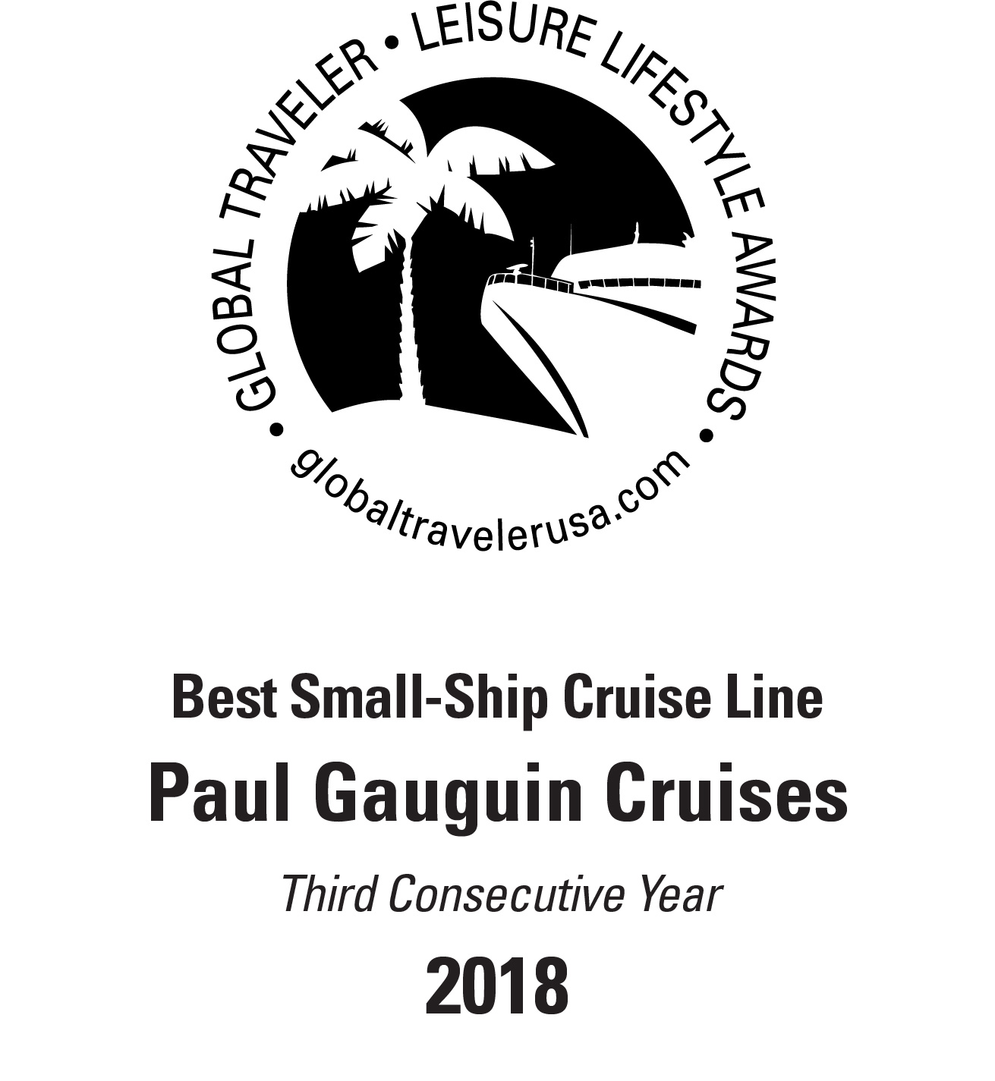
BELLEVUE, WASH. – May 11, 2018 – Paul Gauguin Cruises (www.pgcruises.com), operator of the highest-rated and longest continually sailing luxury cruise ship in the South Pacific, the m/s Paul Gauguin, received the award for “Best Small-Ship Cruise Line” for the third consecutive year during Global Traveler’s 6th Annual Leisure Lifestyle Awards ceremony on May 10, 2018, at the Sofitel Los Angeles at Beverly Hills.

Paul Gauguin Cruises was also recognized in another awards category—in the top five “Best Luxury Cruise Lines.”

Global Traveler is a monthly magazine for business and leisure luxury travelers and conducted a survey of its readers for "the best" in categories across leisure, luxury, and lifestyle travel. Awards were given to the best leisure destinations, airlines, cruise lines, hotels, and tour operators voted by Global Traveler’s readers.

“We are thrilled to be voted ‘Best Small-Ship Cruise Line’ again this year,” remarked Diane Moore, President of Paul Gauguin Cruises, who accepted the award at the ceremony. “Thank you to Global Traveler and its readers for this prestigious honor. It’s a testament to our dedicated staff, who delivers extraordinary service aboard our voyages in Tahiti, French Polynesia, Fiji, and the South Pacific.”

The winners are listed in the Leisure Lifestyle Edition of Global Traveler, available on newsstands May 15, 2018, and online at www.globaltravelerusa.com.

For more information about Paul Gauguin Cruises, please contact a Travel Professional, call 800-848-6172, or visit www.pgcruises.com.
###
About Paul Gauguin Cruises
Owned by Pacific Beachcomber S.C., French Polynesia’s leading luxury hotel and cruise operator, Paul Gauguin Cruises operates the 5+-star cruise ship, the 332-guest m/s Paul Gauguin, providing a deluxe cruise experience tailored to the unparalleled wonders of Tahiti, French Polynesia, and the South Pacific. Paul Gauguin Cruises has been recognized by notable publications in travel and lifestyle and was voted “#1 Midsize-Ship Ocean Cruise Line” by readers in the Travel + Leisure World’s Best Awards 2017†. The line was also recognized as one of the “Top Small Cruise Lines” in the Condé Nast Traveler 2017 Readers’ Choice Awards and is honored on the publication’s 2018 “Gold List.” Paul Gauguin Cruises was also selected as “Best Small-Ship Cruise Line” in Global Traveler’s Leisure Lifestyle Awards in 2016 and 2017, and received top honors as the “#1 Cruise Line for Honeymooners” in BRIDES Magazine’s 2017 Honeymoon Awards and listed in the publication’s “Top All-Inclusives” in the 2018 Honeymoon Awards.

Media Contact:
Vanessa Bloy
Paul Gauguin Cruises
Director of Public Relations
(425) 440-6255
vbloy@pgcruises.com

†From Travel + Leisure Magazine, August 2017 © Time Inc. Affluent Media Group. Used under license. Travel + Leisure and Time Inc. Affluent Media Group are not affiliated with, and do not endorse products or services of, Paul Gauguin Cruises.

