PAUL GAUGUIN CRUISES IS AWARDED “TOP SMALL-SHIP CRUISE LINE FOR FAMILIES” BY TRAVEL + LEISURE
IN THE MAGAZINE’S 2013 “WORLD’S BEST AWARDS”

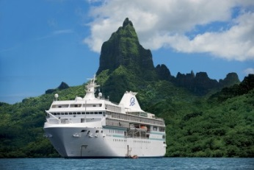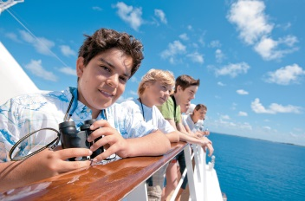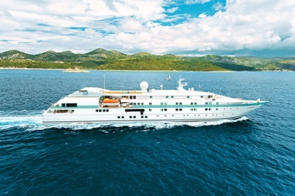

BELLEVUE, WASH. – July 24, 2013 – Paul Gauguin Cruises (www.pgcruises.com), operator of the highest-rated and longest continually sailing luxury cruise ship in the South Pacific, the m/s Paul Gauguin, and the 90-guest m/v Tere Moana, is pleased to announce that it received the award for “Top Small-Ship Cruise Line for Families” voted by the readers of Travel + Leisure magazine at the “World’s Best Awards” gala event held Thursday, July 18, 2013, in New York City.

“We are thrilled to be the number-one small-ship cruise line for families,” said Diane Moore, President of Paul Gauguin Cruises. “Thank you to the readers of Travel + Leisure for this special award along with the high marks we received in service and small-ship categories.”

During the awards ceremony, Travel + Leisure recognized the line’s Ambassadors of the Environment Youth Program, which is offered on summer and holiday sailings to families aboard The Gauguin. Oceanographer and environmentalist Jean-Michel Cousteau and his Ocean Futures Society created this unique, groundbreaking program which introduces young travelers (ages 9 to 17) to the extraordinary natural wonders of French Polynesia through direct, hands-on, interactive experiences with marine and island ecosystems. Participants explore coral reefs, hike rainforest trails, and visit marae (ancient Polynesian temples), and also learn how black pearls and vanilla are cultivated and how volcanic islands become coral atolls. Parents are encouraged to join their children on eco-excursions and other activities aboard and ashore.

In addition to this award, Paul Gauguin Cruises was also listed as one of Travel + Leisure’s “World’s Best Small-Ship Cruise Lines” of 2013 and honored on the magazine’s “World’s Best Service 2013” list in June in the category of “Top Cruises: Small Ships.”

The magazine’s prestigious annual readers’ survey reveals favorite cities, hotels, islands, cruise lines, spas, airlines, airports, and more. Cruise lines were rated in categories of cabins, restaurants/food, service, itineraries/destinations, excursions, activities, and value.

The full list of “World’s Best Awards” winners is available at www.travelandleisure.com and in the August issue of Travel + Leisure magazine, on newsstands now. Travel + Leisure’s “World’s Best Family” winners, which spotlight the best adventure outfitters, cruise lines, and hotels, will be featured in the magazine’s November issue.

In addition, to the Travel + Leisure accolades, Paul Gauguin Cruises has been honored by other notable names in travel including by readers of Condé Nast Traveler as one of the “Top 20 Small Cruise Ships” for 15 years in a row, by Travel Weekly with a Gold Magellan and two Silver Magellan awards in the small ship category, by Porthole Cruise Magazine for “Best South Pacific Itinerary,” and by Cruise Critic for service, dining, entertainment, staterooms, public spaces, value, and shore excursions.

###

About Paul Gauguin Cruises
Owned by Pacific Beachcomber S.C., French Polynesia’s leading luxury hotel and cruise operator, Paul Gauguin Cruises operates the 5+-star cruise ship, the 332-guest m/s Paul Gauguin, providing a deluxe cruise experience tailored to the unparalleled wonders of Tahiti, French Polynesia, the South Pacific, and Southeast Asia. It is one of the top exclusive charter and incentive group venues in the industry and has completed more than 570 South Pacific cruises, serving more than 176,250 guests, including more than 15,000 honeymooners, since its inaugural sail in 1998. The Gauguin’s accolades include recognition as “Top Small-Ship Cruise Line for Families” in Travel + Leisure’s 2013 “World’s Best Awards” and one of the “Top 20 Small Cruise Ships” in 2013 for the 15th year in a row by readers of Condé Nast Traveler.

In December 2012, the m/v Tere Moana began sailing under the Paul Gauguin Cruises banner after completing a multifaceted renovation and offers voyages in the Caribbean, Latin America, and Europe. At 330 feet long and 46 feet wide, The Moana has a draft of 11.5 feet, and accommodates 90 guests with a staff of 60.

For additional information on Paul Gauguin Cruises, please visit www.pgcruises.com.
Media Contact:
Paul Gauguin Cruises
Vanessa Bloy, Director of Public Relations
(425) 440-6255
vbloy@pgcruises.com

