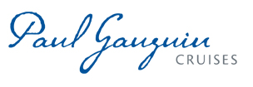
PAUL GAUGUIN CRUISES CELEBRATES CLIA’s “PLAN A CRUISE MONTH” WITH SPECIAL OFFER
$100 Per-Person Shipboard Credit on 2017 and 2018 Tahiti, French Polynesia & South Pacific Sailings

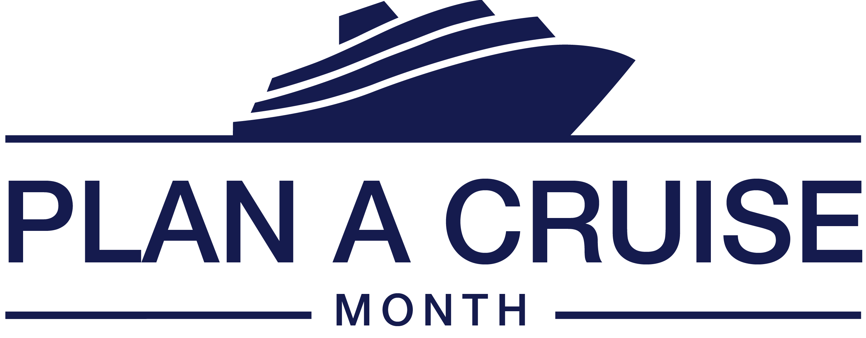

BELLEVUE, WASH. – September 28, 2017 – Paul Gauguin Cruises (www.pgcruises.com), operator of the highest-rated and longest continually sailing luxury cruise ship in the South Pacific, the m/s Paul Gauguin, is taking part in Cruise Lines International Association’s “Plan a Cruise Month” campaign, October 1-31, 2017.

This multidimensional campaign celebrates cruise travel and is designed as a point of discovery and a way to inspire travelers to plan and book cruise vacations. During the month of October, the cruise industry is featuring exceptional savings and special offers on cruise vacations.

Those who book a 2017 or 2018 sailing aboard The Gauguin during “Plan a Cruise Month” will receive $100 per-person Shipboard Credit. This Shipboard Credit can be used to indulge in a spa treatment in Deep Nature Spa, purchase a souvenir in La Boutique, or book a shore excursion aboard. Paul Gauguin Cruises is also offering savings of 50% off standard all-inclusive cruise fares on all voyages, plus included airfare from Los Angeles. To give travelers a greater opportunity to take advantage of this special offer, Paul Gauguin Cruises is extending the booking period until November 11, 2017.

To learn more about cruise line deals and promotions during “Plan a Cruise Month” and locate a CLIA-certified cruise specialist, visit www.cruising.org.

For additional information on Paul Gauguin Cruises, please contact a Travel Professional, call 800-848-6172, or visit www.pgcruises.com.

New bookings only. Please mention booking code CLIA1002017. Offer may be combined with 3rd guest in stateroom offer and applicable past guest savings but is not combinable with other offers, including Two-Week Sales. Port, security, and handling charges are additional. Maximum $200 Shipboard Credit per stateroom. Shipboard Credit may be used to purchase shore excursions aboard ship but not in advance of sailing. Shipboard Credit offer expires November 11, 2017. Call for details.
###
About Paul Gauguin Cruises
Owned by Pacific Beachcomber S.C., French Polynesia’s leading luxury hotel and cruise operator, Paul Gauguin Cruises operates the 5+-star cruise ship, the 332-guest m/s Paul Gauguin, providing a deluxe cruise experience tailored to the unparalleled wonders of Tahiti, French Polynesia, and the South Pacific. Paul Gauguin Cruises has been recognized by notable publications in travel and lifestyle and was recently voted “#1 Midsize-Ship Ocean Cruise Line” by readers in the Travel + Leisure World’s Best Awards 2017†. The line was also awarded #2 in the category of “Top Small Cruise Lines” in the Condé Nast Traveler 2016 Readers’ Choice Awards and recognized on the publication’s 2016 “Gold List.” Paul Gauguin Cruises was also selected as “Best Small-Ship Cruise Line” in Global Traveler’s Leisure Lifestyle Awards in 2016 and 2017, and recently received top honors as the “#1 Cruise Line for Honeymooners” in BRIDES Magazine’s 2017 Honeymoon Awards.

Media Contact:
Paul Gauguin Cruises
Vanessa Bloy, Director of Public Relations
(425) 440-6255
vbloy@pgcruises.com

†From Travel + Leisure Magazine, August 2017 © Time Inc. Affluent Media Group. Used under license. Travel + Leisure and Time Inc. Affluent Media Group are not affiliated with, and do not endorse products or services of, Paul Gauguin Cruises.

