PAUL GAUGUIN CRUISES DEBUTS ITS 2017 TAHITI, FRENCH POLYNESIA, FIJI & THE SOUTH PACIFIC BROCHURE
Featuring Luxurious, Small-Ship Voyages to Exotic South Seas Destinations

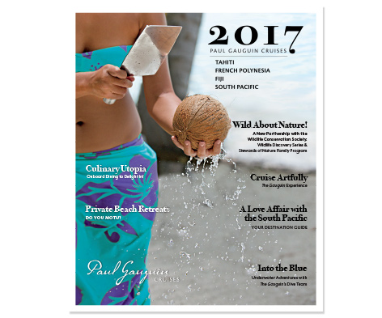

BELLEVUE, WASH. – August 24, 2016 – Paul Gauguin Cruises (www.pgcruises.com), operator of the highest-rated and longest continually sailing luxury cruise ship in the South Pacific, the m/s Paul Gauguin, debuts its 2017 Tahiti, French Polynesia, Fiji & the South Pacific brochure.

The colorful, 82-page brochure takes a fresh approach for 2017 with an entertaining magazine format, which features rich destination content and beautiful visuals that celebrate Polynesian culture and introduce and educate audiences about Paul Gauguin Cruises and the voyages offered.

The brochure, which can be viewed online, showcases a variety of dream cruises, day-by-day itineraries, maps, highlights, and fares. The Gauguin experience, fleet distinctions, dining venues, private retreats, entertainment options, special occasions, activities, shore excursions, SCUBA diving and watersports options, pre- and post-cruise hotel programs, deck plans, and sailing schedule are also highlighted.

The Gauguin’s 2017 sailings feature its most popular voyages and showcase a host of exquisite islands with white-sand beaches, aqua lagoons, mist-laden mountains, and warm Polynesian culture. Itineraries include: 7-night Tahiti & the Society Islands; 7-night Tahiti, the Society Islands & Tuamotus; 10-night Society Islands & Tuamotus; 10-night Cook Islands & Society Islands Reunion Cruise; 11-night Cook Islands & Society Islands; 14-night Marquesas, Tuamotus & Society Islands; and 12- and 13-night Fiji, Tonga, Cook & Society Islands.

New for 2017 are exotic 16- and 17-night Fiji & Bali itineraries. The 16-night Fiji to Bali voyage departs April 29, 2017, from Lautoka, Fiji, and visits Espiritu Santo, Vanuatu; Guadalcanal, Solomon Islands; Samarai Island, Papua New Guinea; Port Moresby, Papua New Guinea; Thursday Island, Australia; Dili, Timor-Leste; Komodo Island, Indonesia; Lembar, Lombok Island, Indonesia; and Benoa, Bali, Indonesia. The reverse itinerary, Bali to Fiji, departs on June 7, 2017, is 17 nights in length, and stays overnight in Lautoka instead of Bali.

In addition to new itineraries in 2017, Paul Gauguin Cruises’ new partnership with the Wildlife Conservation Society (WCS) provides two interactive, educational programs to enrich guests’ experience on board. During the summer months and holiday season, Stewards of Nature is offered and invites children ages 7 to 17, as well as their families, to discover and value nature through hands-on interactive learning. The Wildlife Discovery Series is an onboard lecture program focusing on the environment and wildlife of our planet presented by some of the world’s most fascinating conservationists, scientists, and oceanographers. Paul Gauguin Cruises is proud to collaborate with WCS in support of a healthy and sustainable planet.

Designed specifically to sail the pristine lagoons of these islands, The Gauguin provides an up-close, authentic experience of the South Seas and offers an elegant yet casual ambiance with luxurious accommodations, gourmet dining, trademark Polynesian hospitality, and extraordinary all-inclusive value. On sailings in French Polynesia, guests also receive complimentary access to Paul Gauguin Cruises’ two exclusive retreats. Off the coast of Taha’a lies the islet of Motu Mahana for enjoying a day of watersports, Polynesian activities, a sumptuous barbecue feast, and cocktails from a floating bar. In Bora Bora, guests can relax on a private, white-sand beach and enjoy refreshments, a game of volleyball, and snorkeling in crystal-clear waters.

Paul Gauguin Cruises provides extraordinary value in luxury cruising and is currently offering savings of 50% off standard all-inclusive cruise fares on all 2017 voyages, plus included roundtrip airfare from Los Angeles on itineraries on The Gauguin. Past guests of Paul Gauguin Cruises enjoy additional savings of 5% off final cruise fares as a member of the Paul Gauguin Society.

For a complimentary copy of the 2017 Tahiti, French Polynesia, Fiji & the South Pacific, please contact a Travel Professional, call 800-848-6172, or visit www.pgcruises.com.

###
About Paul Gauguin Cruises
Owned by Pacific Beachcomber S.C., French Polynesia’s leading luxury hotel and cruise operator, Paul Gauguin Cruises operates the 5+-star cruise ship, the 332-guest m/s Paul Gauguin, providing a deluxe cruise experience tailored to the unparalleled wonders of Tahiti, French Polynesia, Fiji, and the South Pacific. Paul Gauguin Cruises accolades include being voted #2 in the category of “Top Small Cruise Lines” in the Condé Nast Traveler 2015 Readers’ Choice Awards and recognition on the publication’s 2016 “Gold List.” In addition, the line was voted by Travel + Leisure readers “#1 Small-Ship Cruise Line” and “#1 Small-Ship Cruise Line for Families” in the Travel + Leisure 2014 World’s Best Awards. Recently, readers voted Paul Gauguin Cruises “#1 Midsize-Ship Ocean Cruise Line” in the Travel + Leisure World’s Best Awards 2016.†
Media Contact:
Paul Gauguin Cruises
Vanessa Bloy, Director of Public Relations
(425) 440-6255
vbloy@pgcruises.com

†From Travel + Leisure, August 2016 ©2016 Time Inc. Affluent Media Group. Used under license. Travel + Leisure and Time Inc. Affluent Media Group are not affiliated with, and do not endorse products or services of Paul Gauguin Cruises.

