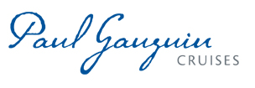
PAUL GAUGUIN CRUISES EXPANDS LAND-AND-SEA PACKAGE PROGRAM

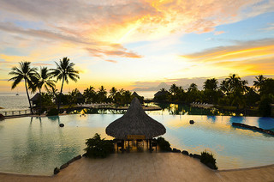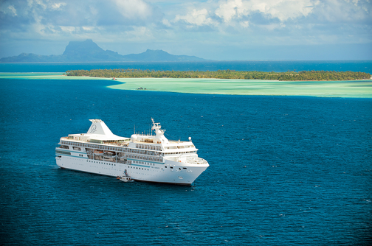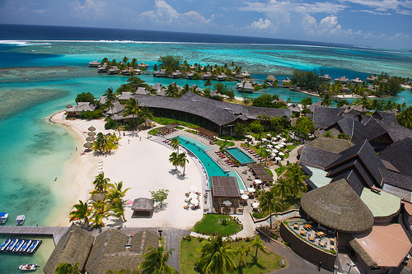

BELLEVUE, WASH. – April 25, 2016 – Paul Gauguin Cruises (www.pgcruises.com), operator of the highest-rated and longest continually sailing luxury cruise ship in the South Pacific, the m/s Paul Gauguin, has expanded its land-and-sea packages so that guests have a choice of combining two nights at the InterContinental Tahiti Resort & Spa or the InterContinental Moorea Resort & Spa with a 7-night Tahiti & the Society Islands voyage. The package also includes roundtrip airfare between Los Angeles, Calif., and Papeete, Tahiti.

After arriving in Papeete, guests check into their lagoon-view room at the InterContinental Tahiti Resort & Spa or take a short ferry ride to the InterContinental Moorea Resort & Spa, where a lanai room awaits. Then, they enjoy two nights with daily breakfast at the property. Upgrades to an overwater lagoon bungalow are also available for an additional cost.

Following the luxury hotel stay, guests are transferred to The Gauguin for a 7-night roundtrip Tahiti & the Society Islands voyage. From Papeete, the ship sails to the scenic islands of Huahine, Bora Bora, and Moorea. A highlight of the cruise is a day spent at Motu Mahana, Paul Gauguin Cruises’ private islet off the coast of Taha’a, which features a barbecue feast, watersports, Polynesian activities, and cocktails from full-service and floating bars. Guests also enjoy exclusive access to a private white-sand beach in Bora Bora with stunning views of Mt. Otemanu.

The hotel-and-cruise package is perfect for anyone who is looking for a longer stay in French Polynesia at a great value and is available on the following select dates:

InterContinental Tahiti Resort & Spa  2-Night Hotel Stay & 7-Night Cruise on The Gauguin | InterContinental Moorea Resort & Spa  2-Night Hotel Stay & 7-Night Cruise on The Gauguin
December 11, 2016 – rates from $4,485 | January 18, 2017 – rates from $4,475
January 11, 2017 – rates from $4,545 | November 8, 2017 – rates from $4,775
November 1, 2017 – rates from $5,245 | November 9, 2016 – rates from $5,775
October 5, 2016 – rates from $5,885 | May 11, 2016 – rates from $5,875
February 15, 2017 – rates from $5,945 | June 15; September 28, 2016 – rates from $5,925
July 6; August 24, 2016 – rates from $6,035 | February 8; September 27, 2017 – rates from $5,975
September 13, 2017 – rates from $6,065 | July 13; August 31, 2016 – rates from $6,075
August 9, 2017 – rates from $6,215 | August 16, 2017 – rates from $6,175

To book a land-and-sea package with Paul Gauguin Cruises, please contact a Travel Professional, call 800-848-6172, or visit www.pgcruises.com.
###

About Paul Gauguin Cruises
Owned by Pacific Beachcomber S.C., French Polynesia’s leading luxury hotel and cruise operator, Paul Gauguin Cruises operates the 5+-star cruise ship, the 332-guest m/s Paul Gauguin, providing a deluxe cruise experience tailored to the unparalleled wonders of Tahiti, French Polynesia, and the South Pacific. Paul Gauguin Cruises accolades include being voted #2 in the category of “Top Small Cruise Lines” in the Condé Nast Traveler 2015 Readers’ Choice Awards and recognition on the publication’s 2016 “Gold List.” In addition, the line was voted by Travel + Leisure readers “#1 Small-Ship Cruise Line” and “#1 Small-Ship Cruise Line for Families” in the Travel + Leisure 2014 World’s Best Awards. Recently, readers voted Paul Gauguin Cruises “#2 Small-Ship Ocean Cruise Line” in the Travel + Leisure 2015 World’s Best Awards.†
Media Contact:
Paul Gauguin Cruises
Vanessa Bloy, Director of Public Relations
(425) 440-6255
vbloy@pgcruises.com

Rates are per person, double occupancy and include roundtrip airfare between Los Angeles and Papeete; 2 nights’ accommodations, a day room, and daily breakfast (Fridays and Saturdays only) at an InterContinental hotel; transfers; and a 7-night cruise aboard the m/s Paul Gauguin. InterContinental Moorea Resort & Spa package also includes roundtrip inter-island ferry transportation and air/ferry/ship transfers. Port, security, and handling charges are additional.

†From Travel + Leisure Magazine, August 2015 ©2015 Time Inc. Affluent Media. Used under license. Travel + Leisure and Time Inc. Affluent Media are not affiliated with, and do not endorse products or services of Paul Gauguin Cruises.

