PAUL GAUGUIN CRUISES OFFERS FREE AMBASSADORS OF THE ENVIRONMENT FAMILY PROGRAM
On the December 21, 2016, Holiday Voyage in French Polynesia

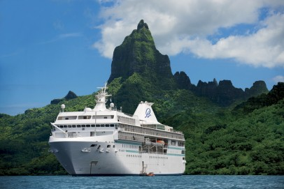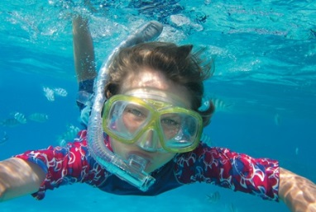

BELLEVUE, WASH. – June 22, 2016 – Paul Gauguin Cruises (www.pgcruises.com), operator of the highest-rated and longest continually sailing luxury cruise ship in the South Pacific, the m/s Paul Gauguin, will offer the Ambassadors of the Environment Family Program free, a value of $329 per child, on the December 21, 2016, 7-night Tahiti & the Society Islands holiday voyage.

Jean-Michel Cousteau and his Ocean Futures Society created the Ambassadors Program, which is a unique, groundbreaking program that introduces young travelers (ages 9-17) to the extraordinary natural wonders of French Polynesia through direct, hands-on, interactive learning. Under the guidance of expert Ocean Futures Society naturalists, this flexible program lets parents and children alike pick and choose from a suite of onboard activities and daily excursions that reveal the natural wonders and rich culture of Polynesia by land and sea. Adults are encouraged to join in for the additional cost of the excursions.

The 7-night Tahiti & the Society Islands holiday cruise departs Papeete, Tahiti, and sails to Huahine, Taha’a (Motu Mahana), Bora Bora (overnight), and Moorea (overnight) in the Society Islands. In addition to cruising to beautiful islands in French Polynesia and highlighting Polynesian culture, this voyage features complimentary access to Paul Gauguin Cruises’ two exclusive retreats—Motu Mahana, an islet off the coast of Taha’a, and a private beach in Bora Bora. At Motu Mahana, guests enjoy a day of watersports, Polynesian activities, a barbecue feast, and cocktails from full-service and floating bars. In Bora Bora, guests can relax on a white-sand beach and enjoy refreshments, a game of volleyball, and snorkeling in crystal-clear waters.
Cruise fares start from $5,545 per person and include roundtrip airfare from Los Angeles. The third guest in a stateroom sails free (cruise only). Additionally, this offer is combinable with the line’s “Best Summer Offer, Ever” promotion which features a $500 per-stateroom Shipboard Credit and reduced deposit of $250 per person.* The Shipboard Credit can be used to indulge in a spa treatment in Deep Nature Spa, purchase a souvenir in La Boutique, or book a shore excursion aboard The Gauguin.

For more information on Paul Gauguin Cruises, contact a Travel Professional, call 800-848-6172, or visit www.pgcruises.com.
###
About Paul Gauguin Cruises
Owned by Pacific Beachcomber S.C., French Polynesia’s leading luxury hotel and cruise operator, Paul Gauguin Cruises operates the 5+-star cruise ship, the 332-guest m/s Paul Gauguin, providing a deluxe cruise experience tailored to the unparalleled wonders of Tahiti, French Polynesia, and the South Pacific. Paul Gauguin Cruises accolades include being voted #2 in the category of “Top Small Cruise Lines” in the Condé Nast Traveler 2015 Readers’ Choice Awards and recognition on the publication’s 2016 “Gold List.” In addition, the line was voted by Travel + Leisure readers “#1 Small-Ship Cruise Line” and “#1 Small-Ship Cruise Line for Families” in the Travel + Leisure 2014 World’s Best Awards. More recently, readers voted Paul Gauguin Cruises “#2 Small-Ship Ocean Cruise Line” in the Travel + Leisure 2015 World’s Best Awards.†

Media Contact:
Paul Gauguin Cruises
Vanessa Bloy, Director of Public Relations
(425) 440-6255
vbloy@pgcruises.com

*Rates are per person based on double occupancy and in US dollars. New bookings only. Offer may be combined with FREE 3rd guest in stateroom offer on December 21, 2016, sailing and applicable past guest savings but may not be combinable with other offers or Groups. Port, security, and handling charges are $119 per person additional. $250 deposit is refundable, less a $100 administrative fee. Shipboard Credits are per stateroom regardless of occupancy. Must book by July 30, 2016. Call for details.
†From Travel + Leisure Magazine, August 2015 ©2015 Time Inc. Affluent Media. Used under license. Travel + Leisure and Time Inc. Affluent Media are not affiliated with, and do not endorse products or services of Paul Gauguin Cruises.

