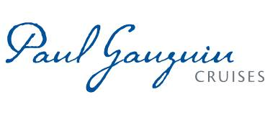
PAUL GAUGUIN CRUISES HONORED IN THE 2017 AFAR TRAVELERS’ CHOICE AWARDS
AS “BEST FRENCH POLYNESIA CRUISE LINE”

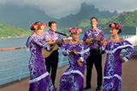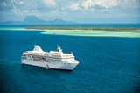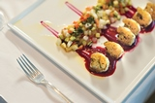

BELLEVUE, WASH. – October 10, 2017 – Paul Gauguin Cruises (www.pgcruises.com), operator of the highest-rated and longest continually sailing luxury cruise ship in the South Pacific, the m/s Paul Gauguin, is pleased to announce that it was the winner of “Best French Polynesia Cruise Line” and was also a finalist in the “Best Small-Ship Cruise Line” and “Best Onboard Culinary Programs and Restaurants” categories in the 2017 AFAR Travelers’ Choice Awards.

“Paul Gauguin Cruises sails year round in French Polynesia, and we are thrilled to receive this special award that celebrates our extraordinary voyages in this destination from AFAR magazine,” said Diane Moore, President, Paul Gauguin Cruises. “We are also honored to be recognized as a finalist in the small-ship and culinary programs and restaurants categories. It is a testament to our talented team that delivers exceptional service and experiences to our guests every day.”

Each year, AFAR magazine asks readers to vote for their favorite cruise lines, hotels, and destinations that capture their imagination and inspire their travel plans in the annual Traveler’s Choice Awards. This year, 130,000 of AFAR’s audience voted. The full list of winners is available at www.afar.com, and the awards are featured in the November/December 2017 “Travel Vanguard” issue of AFAR magazine.

Paul Gauguin Cruises offers 7- to 14-night voyages in Tahiti, French Polynesia, and the South Pacific year round. Designed specifically to sail the pristine lagoons of the destination, The Gauguin provides an up-close, authentic experience of the South Seas and offers an elegant yet casual ambiance with luxurious accommodations, gourmet dining in three dining venues, trademark Polynesian hospitality, and extraordinary all-inclusive value.

For more information or reservations, contact a professional travel agent, call 1-800-848-6172, or visit www.pgcruises.com.
###
About Paul Gauguin Cruises
Owned by Pacific Beachcomber S.C., French Polynesia’s leading luxury hotel and cruise operator, Paul Gauguin Cruises operates the 5+-star cruise ship, the 332-guest m/s Paul Gauguin, providing a deluxe cruise experience tailored to the unparalleled wonders of Tahiti, French Polynesia, and the South Pacific. Paul Gauguin Cruises has been recognized by notable publications in travel and lifestyle and was recently voted “#1 Midsize-Ship Ocean Cruise Line” by readers in the Travel + Leisure World’s Best Awards 2017†. The line was also awarded #2 in the category of “Top Small Cruise Lines” in the Condé Nast Traveler 2016 Readers’ Choice Awards and recognized on the publication’s 2016 “Gold List.” Paul Gauguin Cruises was also selected as “Best Small-Ship Cruise Line” in Global Traveler’s Leisure Lifestyle Awards in 2016 and 2017, and recently received top honors as the “#1 Cruise Line for Honeymooners” in BRIDES Magazine’s 2017 Honeymoon Awards.

Media Contact:
Paul Gauguin Cruises
Vanessa Bloy, Director of Public Relations
(425) 440-6255/vbloy@pgcruises.com

†From Travel + Leisure Magazine, August 2017 © Time Inc. Affluent Media Group. Used under license. Travel + Leisure and Time Inc. Affluent Media Group are not affiliated with, and do not endorse products or services of, Paul Gauguin Cruises.

