PAUL GAUGUIN CRUISES HONORED IN CONDÉ NAST TRAVELER 2015 READERS’ CHOICE AWARDS
IN THE CATEGORY OF TOP SMALL CRUISE LINES

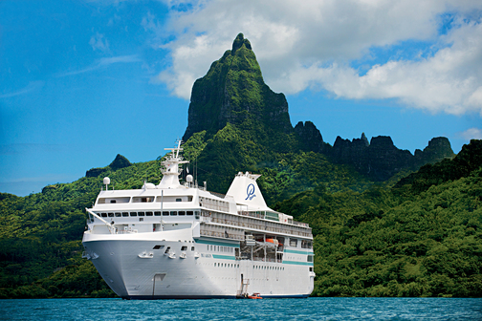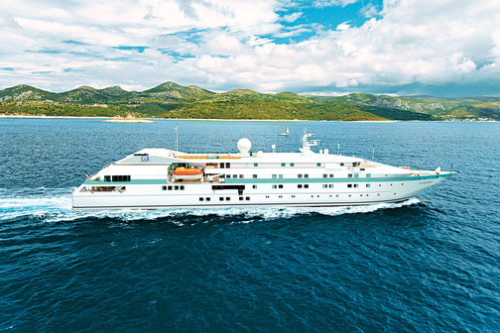

BELLEVUE, WASH. – October 22, 2015 – Paul Gauguin Cruises (www.pgcruises.com), operator of the highest-rated and longest continually sailing luxury cruise ship in the South Pacific, the m/s Paul Gauguin, and the 88-guest m/v Tere Moana, which sails Europe, the Caribbean, and Latin America, is pleased to announce that the line was honored in the Condé Nast Traveler 2015 Readers’ Choice Awards, ranking #2 in the category of “Top Small Cruise Lines.”

“Thank you to the readers of Condé Nast Traveler who voted Paul Gauguin Cruises to the prestigious ‘Top Small Cruise Lines’ list,” said Diane Moore, President of Paul Gauguin Cruises. “Every day our talented and dedicated staff delivers exceptional experiences aboard our voyages, and we are thrilled to be recognized again this year.”

In the annual poll, readers ranked the best hotels, resorts, cities, islands, airlines, and cruise lines in the world. The full list of winners can be found on the magazine's website at www.cntraveler.com and are also featured in the November 2015 issue of Condé Nast Traveler.

In addition to the Condé Nast Traveler Readers’ Choice accolades, Paul Gauguin Cruises was recently voted “#2 Small-Ship Ocean Cruise Line” by readers in the Travel + Leisure 2015 World’s Best Awards*.

For more information or reservations for Paul Gauguin Cruises, contact a professional travel agent, call 1-800-848-6172, or visit www.pgcruises.com.

###
About Paul Gauguin Cruises
Owned by Pacific Beachcomber S.C., French Polynesia’s leading luxury hotel and cruise operator, Paul Gauguin Cruises operates the 5+-star cruise ship, the 332-guest m/s Paul Gauguin, providing a deluxe cruise experience tailored to the unparalleled wonders of Tahiti, French Polynesia, and the South Pacific. The m/v Tere Moana offers voyages in the Caribbean, Latin America, and Europe, accommodating 88 guests with a staff of 62.

Media Contact:
Paul Gauguin Cruises
Vanessa Bloy, Director of Public Relations
(425) 440-6255
vbloy@pgcruises.com
*From Travel + Leisure Magazine, August 2015 ©2015 Time Inc. Affluent Media. Used under license. Travel + Leisure and Time Inc. Affluent Media are not affiliated with, and do not endorse products or services of Paul Gauguin Cruises.

