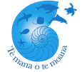 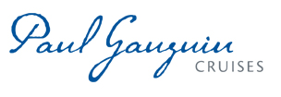

**PAUL GAUGUIN CRUISES OFFERS NEW MOANA EXPLORER PROGRAM**

**ON SUMMER AND HOLIDAY VOYAGES IN PARTNERSHIP WITH TE MANA O TE MOANA**

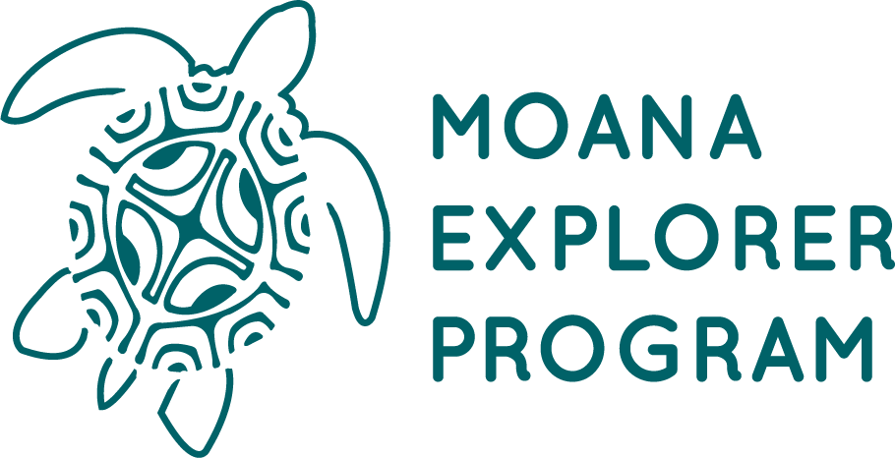

**BELLEVUE, WASH. – June 10, 2019** – **Paul Gauguin Cruises** ([www.pgcruises.com](http://www.pgcruises.com)), operator of the highest-rated and longest continually sailing luxury cruise ship in the South Pacific, the m/s *Paul Gauguin*, is offering the **Moana Explorer program**—a new way for families to explore Tahiti, French Polynesia, and the South Pacific together during summer and holiday voyages.

In partnership with **Te mana o te moana** ([www.temanaotemoana.org](https://www.temanaotemoana.org/)), a South Pacific marine education and conservation foundation, the Moana Explorer program invites children and teens, ages 7-15, to discover and value the natural wonders of the South Pacific through hands-on, interactive learning on board and ashore.

Every day of the voyage, there is a combination of naturalist-led island and/or beach excursions, science activities, crafts, games, and other adventures. Depending on the itinerary, children and teens might explore underwater life, conduct water experiments, create natural jewelry, go on a treasure hunt, learn about Tahitian culture, discover island legends and geology, design a Polynesian tattoo, and more.

The Moana Explorer program is available on the following voyages in 2019:

|  |  |
| --- | --- |
| **7-Night *Tahiti & the Society Islands***   * July 20, 2019 * December 21, 2019 (Holiday Cruise) * December 28, 2019 (Holiday Cruise)   **7-Night *Society Islands & Tahiti Iti***   * July 27, 2019 | **10-Night *Society Islands & Tuamotus***   * July 10, 2019 * August 14, 2019   **11-Night *Cook Islands & Society Islands***   * June 15, 2019 * August 3, 2019 |

There is no fee for the program and it is included as part of Paul Gauguin Cruises’ all-inclusive cruise fares. Guests are encouraged to reserve the program at the time of booking or any time before their sailing date. The program can also be booked on board if space is available. For more information about the Moana Explorer program and daily schedules, [click here](https://www.pgcruises.com/family).

For more information about Paul Gauguin Cruises, please contact a Travel Advisor, call 800-848-6172, or visit [www.pgcruises.com](http://www.pgcruises.com).

###

**About Te mana o te moana**

[Te mana o te moana](http://www.temanaotemoana.org) is a nonprofit organization recognized of General Interest, member of the IUCN and Mission Blue, whose mission is to act for the protection of the Polynesian marine environment and more specifically sea turtles through actions of discovery, education, and protection. Since 2004, Te mana o te moana has welcomed and cared for more than 500 sea turtles at the Sea turtle care center in Moorea and has educated more than 90,000 children on environmental issues. On Tetiaroa atoll, the nonprofit organization’s teams have observed and protected thousands of green sea turtle hatchlings and collected crucial data on the impact of climate changes and predation on Tetiaroa green sea turtle nesting sites. Learn more about Te mana o te moana at the organization’s [website](http://www.temanaotemoana.org) or follow them on [Facebook](https://www.facebook.com/temanaotemoana.moorea/), [Instagram](https://www.instagram.com/temanaotemoana/) and [YouTube](https://www.youtube.com/channel/UCNoLoUx4kqZnO8Eu0KGvd8A).

**About Paul Gauguin Cruises**

Owned by Pacific Beachcomber S.C., French Polynesia’s leading luxury hotel and cruise operator, Paul Gauguin Cruises operates the 5+-star cruise ship, the 332-guest m/s *Paul Gauguin*, providing a deluxe cruise experience tailored to the unparalleled wonders of Tahiti, French Polynesia, and the South Pacific. Paul Gauguin Cruises has been recognized by notable publications in travel and lifestyle and was voted “#2 Midsize-Ship Ocean Cruise Line” by readers in the *Travel + Leisure* World’s Best Awards 2018*. The line was also recognized as one of the “Top Small Cruise Lines” in the *Condé Nast Traveler* 2018 Readers’ Choice Awards and is honored on the publication’s 2018 “Gold List.” Paul Gauguin Cruises was also selected as “Best Small-Ship Cruise Line” in *Global Traveler’s* Leisure Lifestyle Awards from 2016 to 2019, and has received top honors in *BRIDES* Magazine’s Honeymoon Awards for the past three years.

**Media Contact:**

Vanessa Bloy

Paul Gauguin Cruises

Director of Public Relations

(425) 440-6255

[vbloy@pgcruises.com](mailto:vbloy@pgcruises.com)

\**From Travel + Leisure Magazine, August 2018 © Time Inc. Affluent Media Group. Used under license. Travel + Leisure and Time Inc. Affluent Media Group are not affiliated with, and do not endorse products or services of, Paul Gauguin Cruises.*