PAUL GAUGUIN CRUISES SUMMER AND HOLIDAY VOYAGES
OFFER STEWARDS OF NATURE FAMILY PROGRAM

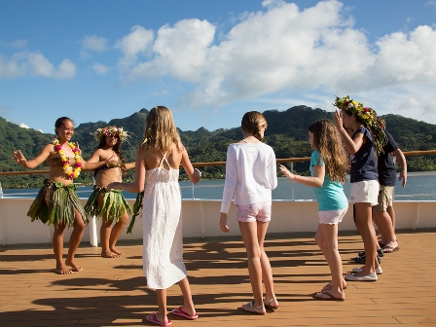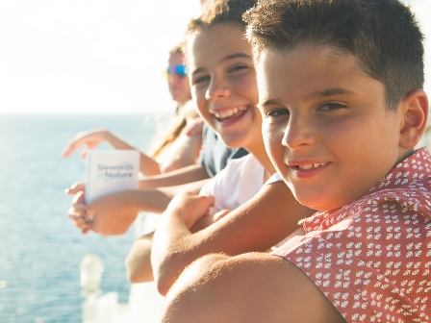

BELLEVUE, WASH. – May 22, 2018 – Paul Gauguin Cruises (www.pgcruises.com), operator of the highest-rated and longest continually sailing luxury cruise ship in the South Pacific, the m/s Paul Gauguin, is offering a way for families to explore Tahiti, French Polynesia, and the South Pacific together this summer and during the holidays through a joint program with the Wildlife Conservation Society (WCS).

The South Pacific is more than a dream destination; it is also a fascinating getaway where families can share activities, strengthen bonds, and create memories to last a lifetime. Through Paul Gauguin Cruises’ partnership with WCS, the Stewards of Nature family program invites children and teens ages 7-17, as well as family members, to discover and value nature through hands-on, interactive learning.
Every day of the voyage, there is a combination of naturalist-led island and/or beach excursions, science activities, crafts, games, and other adventures. Depending on the itinerary, children might learn about underwater life during a snorkeling excursion, observe the ocean or the stars through binoculars or an onboard telescope, and learn about different kinds of marine life and their habitats. Other activities include going on a dolphin-watching expedition, swimming with sharks and rays, playing beach games, enjoying a Tahitian dance performance on board, and learning what it means to be a Steward of Nature.
All of the activities with the program are included for children and teens through a nominal fee ($349-$399, depending on length of voyage). Family members are invited and encouraged to participate in most activities for the additional cost of the shore excursions.
The Stewards of Nature family program is available on the following voyages:

7-Night Tahiti & the Society Islands  - June 16, 2018  - June 23, 2018  - July 28, 2018  - December 22, 2018 (Holiday Cruise)  - December 29, 2018 (Holiday Cruise)  7-Night Society Islands & Tahiti Iti  - June 30, 2018 | 10-Night Society Islands & Tuamotus  - June 6, 2018  - July 18, 2018  11-Night Cook Islands & Society Islands  - July 7, 2018
For more information about the Stewards of Nature program and daily schedules, click here.

For more information about Paul Gauguin Cruises, please contact a Travel Professional, call 800-848-6172, or visit www.pgcruises.com.
###
About the Wildlife Conservation Society
WCS has been committed to saving wildlife and wild places for over 120 years. In addition to being among the world’s leading science and conservation organizations, WCS manages the largest urban network of zoological parks, educating and inspiring millions of people at the New York Zoos and Aquarium. For more information on WCS, please visit www.wcs.org

About Paul Gauguin Cruises
Owned by Pacific Beachcomber S.C., French Polynesia’s leading luxury hotel and cruise operator, Paul Gauguin Cruises operates the 5+-star cruise ship, the 332-guest m/s Paul Gauguin, providing a deluxe cruise experience tailored to the unparalleled wonders of Tahiti, French Polynesia, and the South Pacific. Paul Gauguin Cruises has been recognized by notable publications in travel and lifestyle and was voted “#1 Midsize-Ship Ocean Cruise Line” by readers in the Travel + Leisure World’s Best Awards 2017†. The line was also recognized as one of the “Top Small Cruise Lines” in the Condé Nast Traveler 2017 Readers’ Choice Awards and is honored on the publication’s 2018 “Gold List.” Paul Gauguin Cruises was also selected as “Best Small-Ship Cruise Line” in Global Traveler’s Leisure Lifestyle Awards in 2018, 2016 and 2017, and received top honors as the “#1 Cruise Line for Honeymooners” in BRIDES Magazine’s 2017 Honeymoon Awards and listed in the publication’s “Top All-Inclusives” in the 2018 Honeymoon Awards.

Media Contact:
Vanessa Bloy
Paul Gauguin Cruises
Director of Public Relations
(425) 440-6255
vbloy@pgcruises.com

†From Travel + Leisure Magazine, August 2017 © Time Inc. Affluent Media Group. Used under license. Travel + Leisure and Time Inc. Affluent Media Group are not affiliated with, and do not endorse products or services of, Paul Gauguin Cruises.

