PAUL GAUGUIN CRUISES OFFERS A TWO-WEEK SALE
ON SELECT 2017 & 2018 TAHITI, FRENCH POLYNESIA, AND SOUTH PACIFIC VOYAGES

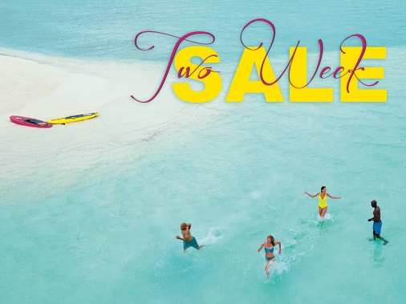

BELLEVUE, WASH. – March 6, 2017 – Paul Gauguin Cruises (www.pgcruises.com), operator of the highest-rated and longest continually sailing luxury cruise ship in the South Pacific, the m/s Paul Gauguin, announces a Two-Week Sale on select 2017 and 2018 Tahiti, French Polynesia, and South Pacific voyages.

Paul Gauguin Cruises is offering savings of up to $4,850* per person off select luxury voyages aboard The Gauguin when booked between March 6 and 18, 2017. Roundtrip airfare between Los Angeles and Papeete, Tahiti, is also included. On board, guests will enjoy the highest standards of luxury, quality, and all-inclusive value sailing to South Pacific destinations that are the cruise line’s specialty. Qualifying voyages are:

Tahiti & the Society Islands (7 nights):
- September 23, 30, 2017 – now from only $5,495 $4,745 per person
- October 28, 2017 – now from only $4,995 $4,145 per person
- November 4, 2017 – now from only $4,695 $3,945 per person

Marquesas, Tuamotus & Society Islands (14 nights):
- November 18, 2017 – now from only $7,395 $5,945 per person

Cook Islands & Society Islands (11 nights):
- December 2, 2017 – now from only $5,895 $4,845 per person
- January 6, 2018 – now from only $6,145 $5,045 per person

Society Islands & Tuamotus (10 nights):
- December 13, 2017 – now from only $5,545 $4,595 per person
- January 17, 2018 – now from only $5,845 $4,845 per person

On The Gauguin, nearly 70% of suites and staterooms offer balconies. Dining experiences include L’Etoile, which showcases an array of culinary creations expertly prepared each evening. The ship’s other two dining venues, La Veranda and Le Grill, serve breakfast and lunch. At night, signature dishes from celebrity chef Jean-Pierre Vigato, world-renowned Chef Propriétaire of the Michelin-rated Restaurant Apicius in Paris, are offered in La Veranda, and Polynesian specialties are served poolside at Le Grill.

Les Gauguines and Les Gauguins—a troupe of Tahitian entertainers—provide enriching experiences of the destinations throughout each voyage. The Gauguin features expert lecturers on each voyage and special guests on select sailings conducting presentations on topics ranging from the history of the South Pacific to conservation, culture, marine life, and the wonders of coral reefs. A luxurious spa, fitness center, watersports marina, and expansive outdoor decks with chaise lounges and a pool are also available aboard The Gauguin.

One of the highlights of each sailing is exclusive access to Motu Mahana, the cruise line’s private islet off the coast of Taha’a where guests can enjoy sunbathing, swimming, snorkeling, kayaking, Polynesian activities, a full-service bar, a floating lagoon bar, and a delicious barbecue. In Bora Bora, guests can enjoy complimentary access to a private, white-sand beach with beach volleyball, sunbathing, snorkeling, paddleboarding, and refreshments.

For more information or reservations, contact a professional travel agent, call 1-800-848-6172, or visit www.pgcruises.com.
###
About Paul Gauguin Cruises
Owned by Pacific Beachcomber S.C., French Polynesia’s leading luxury hotel and cruise operator, Paul Gauguin Cruises operates the 5+-star cruise ship, the 332-guest m/s Paul Gauguin, providing a deluxe cruise experience tailored to the unparalleled wonders of Tahiti, French Polynesia, Fiji, and the South Pacific. Paul Gauguin Cruises accolades include being voted #2 in the category of “Top Small Cruise Lines” in the Condé Nast Traveler 2016 Readers’ Choice Awards and recognition on the publication’s 2016 “Gold List.” In addition, the line was voted by Travel + Leisure readers “#1 Small-Ship Cruise Line” and “#1 Small-Ship Cruise Line for Families” in the Travel + Leisure 2014 World’s Best Awards. Recently, readers voted Paul Gauguin Cruises “#1 Midsize-Ship Ocean Cruise Line” in the Travel + Leisure World’s Best Awards 2016.†
Media Contact:
Paul Gauguin Cruises
Vanessa Bloy, Director of Public Relations
(425) 440-6255
vbloy@pgcruises.com

*All fares are in US dollars, per person, based on double occupancy in lowest stateroom category, and reflect promotional savings, are for new bookings only, are subject to availability, and must be booked by March 18, 2017. Offer may be combined with applicable 3rd guest in stateroom offer and applicable past guest savings but may not be combined with other offers. Port, security, and handling charges of $129-$260 per person are additional. Additional terms and conditions may apply. Call for details. For full terms and conditions, visit www.pgcruises.com.

†From Travel + Leisure, August 2016 ©2016 Time Inc. Affluent Media Group. Used under license. Travel + Leisure and Time Inc. Affluent Media Group are not affiliated with, and do not endorse products or services of Paul Gauguin Cruises.

