PAUL GAUGUIN CRUISES PRESENTS ITS 2017 VOYAGES BROCHURE
Featuring Tahiti, French Polynesia, Fiji, and South Pacific Itineraries

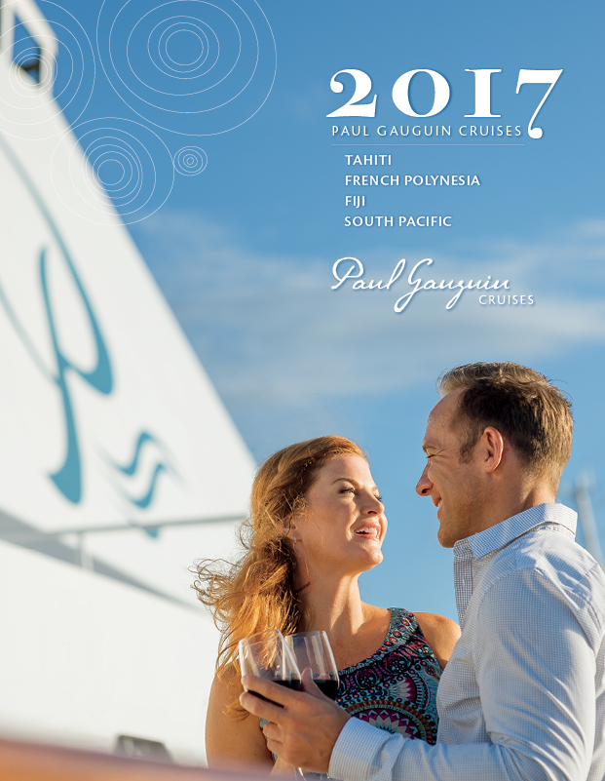

BELLEVUE, WASH. – March 11, 2016 – Paul Gauguin Cruises (www.pgcruises.com), operator of the highest-rated and longest continually sailing luxury cruise ship in the South Pacific, the m/s Paul Gauguin, releases its new 2017 Voyages brochure featuring Tahiti, French Polynesia, Fiji and South Pacific itineraries.

The brochure presents sailings by The Gauguin, which offers an elegant yet casual ambiance, luxurious accommodations, gourmet dining, trademark Polynesian hospitality, and extraordinary all-inclusive value. Fleet distinctions, dining venues, entertainment, activities, private retreats, destination guides, deck plans, and sailing schedules are also highlighted. To view the brochure online, please click here.

In 2017, new, exotic itineraries are offered including a 16-night Fiji to Bali voyage that departs April 29, 2017, from Lautoka, Fiji, and visits Espiritu Santo, Vanuatu; Guadalcanal, Solomon Islands; Samarai Island, Papua New Guinea; Port Moresby, Papua New Guinea; Merauke, Indonesia; Dili, Timor-Leste; Komodo Island, Indonesia; Lembar, Lombok Island, Indonesia; and Benoa, Bali, Indonesia. The reverse itinerary, Bali to Fiji, is 17 nights and departs June 7, 2017.

In 2017, The Gauguin will also be showcasing its most sought-after itineraries: the 7-night Tahiti & the Society Islands; 7-night Tahiti, the Society Islands & Tuamotus; 10-night Society Islands & Tuamotus; 11-night Cook Islands & Society Islands; and 14-night Marquesas, Tuamotus & Society Islands. Popular 12- and 13-night Society Islands, Cook Islands, Tonga & Fiji itineraries return in 2017, too. In addition to sailing to beautiful islands in the South Pacific and showcasing Polynesian culture, these voyages feature complimentary access to Paul Gauguin Cruises’ two exclusive retreats—Motu Mahana, an islet off the coast of Taha’a, and a private beach in Bora Bora. At Motu Mahana, guests enjoy a day of watersports, Polynesian activities, a barbecue feast, and cocktails from full-service and floating bars. In Bora Bora, guests can relax on a white-sand beach and enjoy refreshments, a game of volleyball, and snorkeling in crystal-clear waters.

On The Gauguin’s July 26, 2017, voyage, Paul Gauguin Cruises will present its third Reunion Cruise, which features a special 10-night Cook Islands & Society Islands itinerary with two visits to the line’s private island paradise of Motu Mahana. Designed as a reunion for past guests of Paul Gauguin Cruises and as a gala welcome for newcomers, it presents a number of unique special events, including a festive dinner, cocktail and block parties, opportunities to mingle with senior staff and crew, and more.

Throughout 2017, the Wildlife Conservation Society (WCS) will offer educational programming aboard The Gauguin. For our Wildlife Discovery Series for adults, WCS will present lectures about marine science and wildlife conservation in the South Pacific and beyond. For our Stewards of Nature program during the summer and holiday seasons, WCS will inspire families and children to value nature through experiential learning. WCS applies science to discover and protect the coral reefs and coastal forests of the South Pacific, which are home to thousands of precious fish, sharks, sea turtles, sea birds, plants, and other species. Paul Gauguin Cruises is proud to support the WCS mission to save wildlife and wild places worldwide.
Paul Gauguin Cruises is offering savings of 50% off standard all-inclusive cruise fares on all 2017 voyages, plus included roundtrip airfare from Los Angeles. For a brochure, rates, or more information on Paul Gauguin Cruises, please contact a Travel Professional, call 800-848-6172, or visit www.pgcruises.com.
###

About Paul Gauguin Cruises
Owned by Pacific Beachcomber S.C., French Polynesia’s leading luxury hotel and cruise operator, Paul Gauguin Cruises operates the 5+-star cruise ship, the 332-guest m/s Paul Gauguin, providing a deluxe cruise experience tailored to the unparalleled wonders of Tahiti, French Polynesia, and the South Pacific. Paul Gauguin Cruises accolades include being voted #2 in the category of “Top Small Cruise Lines” in the Condé Nast Traveler 2015 Readers’ Choice Awards and being honored on the publication’s esteemed 2016 Gold List. In addition, the line was voted by Travel + Leisure readers “#1 Small-Ship Cruise Line” and “#1 Small-Ship Cruise Line for Families” in the Travel + Leisure 2014 World’s Best Awards. Readers voted Paul Gauguin Cruises “#2 Small-Ship Ocean Cruise Line” in the Travel + Leisure 2015 World’s Best Awards.†
Media Contact:
Paul Gauguin Cruises
Vanessa Bloy, Director of Public Relations
(425) 440-6255
vbloy@pgcruises.com

†From Travel + Leisure Magazine, August 2015 ©2015 Time Inc. Affluent Media. Used under license. Travel + Leisure and Time Inc. Affluent Media are not affiliated with, and do not endorse products or services of Paul Gauguin Cruises.

