m/s PAUL GAUGUIN RECEIVES ACCOLADES IN 2012 CRUISE CRITIC CRUISERS’ CHOICE AWARDS
For Shore Excursions, Dining, Embarkation, Entertainment, Service, Value, Cabins, and Fitness

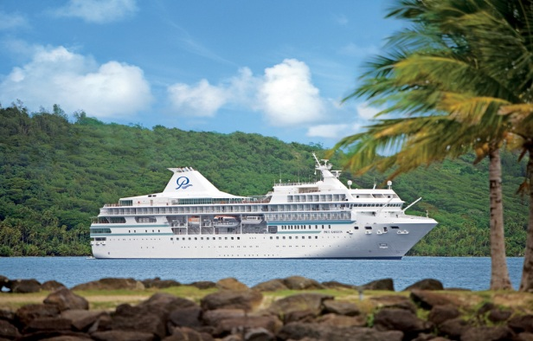
BELLEVUE, WASH. – March 15, 2012 – Paul Gauguin Cruises (www.pgcruises.com), operator of the highest-rated and longest continually sailing luxury cruise ship in the South Pacific, the m/s Paul Gauguin, received accolades from Cruise Critic, the critically acclaimed website with an interactive community comprised of avid and first-time cruisers, in its “2012 Cruisers’ Choice Awards.” The Gauguin garnered high rankings for shore excursions, dining, embarkation, entertainment, service, value, cabins, and fitness on Cruise Critic’s small-ship top 10 list.

The Gauguin’s rankings by category:
- #1 for Best Shore Excursions
- #2 for Best Dining
- #3 for Best Embarkation
- #3 for Best Entertainment
- #3 for Best Service
- #3 for Best Value
- #4 for Best Overall
- #4 for Best Cabins
- #4 for Best Fitness

Rankings were based on ratings given by Cruise Critic members in published 2011 member reviews. Ships must have a minimum number of reviews and ratings to qualify in each category. The full list of top cruise ships can be found on Cruise Critic’s website www.cruisecritic.com.

Paul Gauguin Cruises’ commitment to providing guests with the most luxurious and enriching cruise vacations to Tahiti, French Polynesia, and the South Pacific has consistently placed The Gauguin on Cruise Critic’s list of top small ships.
###

About Paul Gauguin Cruises
Owned by Pacific Beachcomber S.C., French Polynesia’s leading luxury hotel and cruise operator, Paul Gauguin Cruises operates the 5+-star cruise ship m/s Paul Gauguin, providing a deluxe cruise experience tailored to the unparalleled wonders of Tahiti, French Polynesia, and the South Pacific. The Gauguin was built at the Chantiers de l’Atlantique shipyard in Saint Nazaire, France. The ship, 513 feet long and 71 feet wide, has a draft of 16.9 feet and can accommodate 332 guests with a staff of 217. It is one of the top Exclusive Charter and Incentive Group venues in the industry and has completed more than 570 South Pacific cruises, serving more than 176,250 guests, including more than 15,000 honeymooners, since its inaugural sail in 1998. The Gauguin has undergone more than $25 million in enhancements, with an additional $7 million completed in January 2012. The Gauguin has been impressively named the 2011 Silver Magellan Award Winner in the Small Cruise Ship category by Travel Weekly and was recognized as one of the “Top 20 Small Cruise Ships” by Condé Nast Traveler in 2012.

Paul Gauguin Cruises also recently announced the acquisition of a second ship, which will begin sailing under the Paul Gauguin Cruises banner in December 2012. With plans to sail to Europe, the Caribbean, and Latin America, this ship will be christened m/v Tere Moana after completing a multifaceted renovation in December 2012. The Moana features 45 staterooms accommodating 90 guests.

For additional information on Paul Gauguin Cruises, please visit www.pgcruises.com.
Media Contact:
Paul Gauguin Cruises
Vanessa Bloy, Director of Public Relations
(425) 440-6255
vbloy@pgcruises.com

