PAUL GAUGUIN CRUISES UNVEILS WEDDING CEREMONY AND RENEWAL OF VOWS PACKAGES
Guests Can Celebrate Their Love on the Private Islet of Motu Mahana or on Bora Bora in French Polynesia

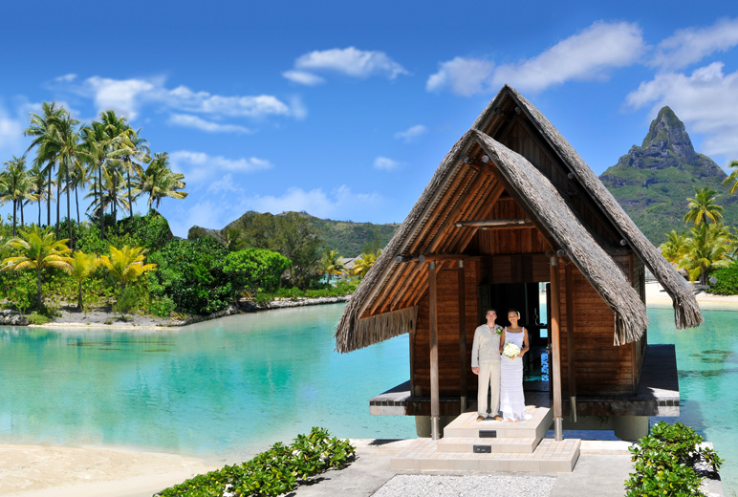

BELLEVUE, WASH. – January 9, 2017 – Paul Gauguin Cruises (www.pgcruises.com), operator of the highest-rated and longest continually sailing luxury cruise ship in the South Pacific, the m/s Paul Gauguin, now offers wedding ceremony and renewal of vows packages at Motu Mahana, the cruise line’s private islet off the coast of Taha’a, or at the InterContinental Bora Bora Resort & Thalasso Spa.

Couples sailing on The Gauguin can celebrate their love in a romantic setting amid the turquoise lagoons and exotic islands of French Polynesia. Two optional packages offer these exclusive features:

Motu Wedding Ceremony or Renewal of Vows*
- Private Polynesian Blessing Ceremony on Motu Mahana
- Congratulatory letter from the Captain
- Invitation to dine with the Captain or Hotel Director
- In-stateroom celebratory bottle of Champagne
- Reception cake and box of chocolates
- Heis (crowns of flowers)
- Deluxe flower arrangement
- One 8"x10" photo portrait

The Motu Wedding Ceremony or Renewal of Vows package is $315.

Bora Bora Wedding Ceremony or Renewal of Vows at Thalasso*
- Bride’s arrival at the chapel on a traditional outrigger canoe ride through the lagoonarium
- Tahitian blessing by a local priest, at the InterContinental Bora Bora Resort & Thalasso Spa’s air-conditioned chapel with glass floors showcasing the lagoon below, and splendid views of Mount Otemanu
- Flower leis for the bride and groom
- Tapa certificate with the couple’s Polynesian name
- 2-course lunch at the resort
- Love lock to attach to a palm tree in the resort’s Secret Garden of Love to seal and symbolize the couple’s eternal love in Polynesian style
- Use of the resort’s facilities after the ceremony
- Transfers

The Bora Bora Wedding Ceremony or Renewal of Vows at Thalasso package is $950. Guests can save $50 by combining it with the “Romantic Escapade” shore excursion or a pre- or post-cruise stay at InterContinental Bora Bora Resort & Thalasso Spa when arranged by Paul Gauguin Cruises.

Paul Gauguin Cruises also offers a gift registry for those celebrating a wedding, honeymoon, or other special occasions at www.pgcruises.celebrationwishes.com.

For reservations, please contact a Travel Professional, call 800-848-6172, or visit www.pgcruises.com.

###
About Paul Gauguin Cruises
Owned by Pacific Beachcomber S.C., French Polynesia’s leading luxury hotel and cruise operator, Paul Gauguin Cruises operates the 5+-star cruise ship, the 332-guest m/s Paul Gauguin, providing a deluxe cruise experience tailored to the unparalleled wonders of Tahiti, French Polynesia, Fiji, and the South Pacific. Paul Gauguin Cruises accolades include being voted #2 in the category of “Top Small Cruise Lines” in the Condé Nast Traveler 2016 Readers’ Choice Awards and recognition on the publication’s 2016 “Gold List.” Recently, readers voted Paul Gauguin Cruises “#1 Midsize-Ship Ocean Cruise Line” in the Travel + Leisure World’s Best Awards 2016.†
Media Contact:
Paul Gauguin Cruises
Vanessa Bloy, Director of Public Relations
(425) 440-6255
vbloy@pgcruises.com

*Wedding ceremony is not legally binding. Limit: 2 Wedding Ceremony and/or Renewals of Vows per sailing, subject to availability. Motu Wedding Ceremony or Renewal of Vows package must be booked at least one week prior to sailing, and availability is subject to weather conditions. Bora Bora Wedding Ceremony or Renewal of Vows package must be booked at least 72 hours prior to sailing and is subject to availability; additional guests may attend by booking the “Day at the Beach” shore excursion at the listed price. Additional services are available for a nominal fee; please call for details. Payment is due upon booking of the event. Cancellation fees apply as follows: 50% for cancellations up to 8 days prior to event; 100% for cancellations 7 days or less prior to event.

†From Travel + Leisure, August 2016 ©2016 Time Inc. Affluent Media Group. Used under license. Travel + Leisure and Time Inc. Affluent Media Group are not affiliated with, and do not endorse products or services of Paul Gauguin Cruises.

