WILDLIFE CONSERVATION SOCIETY SCIENTISTS EMILY DARLING AND SANGEETA MANGUBHAI LECTURE AS PART OF PAUL GAUGUIN CRUISES’ NEW WILDLIFE DISCOVERY SERIES

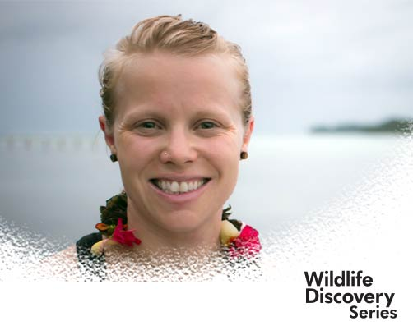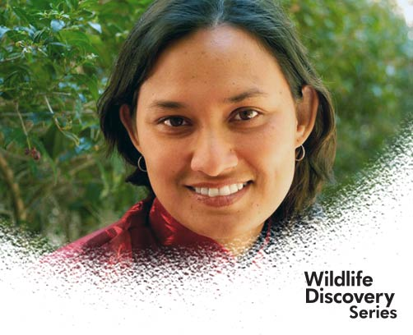

BELLEVUE, WASH. – February 28, 2017 – Paul Gauguin Cruises (www.pgcruises.com), operator of the highest-rated and longest continually sailing luxury cruise ship in the South Pacific, the m/s Paul Gauguin, is pleased to announce, in partnership with Wildlife Conservation Society (WCS), that guest scientists Emily Darling, Associate Director of WCS Global Marine Programs, and Sangeeta Mangubhai, Director of WCS Fiji, will lecture as part of the new Wildlife Discovery Series program aboard The Gauguin.

The Wildlife Discovery Series is a lecture program where guests of The Gauguin have the opportunity to learn about marine wildlife and habitats from some of the world’s most fascinating scientists, oceanographers, and conservationists. Darling and Mangubhai will share their research and expertise on coral reefs and climate change, conservation challenges and opportunities in Melanesia, and WCS conservation approaches in Fiji, during The Gauguin’s June 7, 2017, Bali to Fiji voyage.

Darling is a dedicated coral reef ecologist, passionate about sustaining tropical corals in a changing climate. In her role at WCS, Darling coordinates a coral reef monitoring program across Melanesia, Indonesia, the Caribbean, and Western Indian Ocean. Her research focuses on fisheries management, community ecology, and coral responses to climate change. In addition to publishing in scientific journals, Darling has contributed to popular science blogs for major media networks.

Darling earned her undergraduate degree at Queen’s University and doctorate at Simon Fraser University. She completed a David H. Smith Conservation Research Fellowship and was recently bestowed a Banting Postdoctoral Fellowship. She has lived and traveled in southeast Asia, Africa, and the northern wilds of Canada and currently resides in Vancouver, British Columbia. She is an expedition diver and underwater photographer and also enjoys hiking, paddling, rock climbing, and exploring the natural world.

Mangubhai has worked for WCS since 2014 and is currently based in Suva, Fiji. As the Director of the WCS Fiji program, she has empowered local communities to make informed decisions about their natural resources. Mangubhai specializes in designing marine protected areas, assessing coral reef resilience, monitoring fisheries, and evaluating the return on investment of conservation action. Throughout her career, she has studied ecology and advised policy in Fiji, Vanuatu, Kiribati, Cook Islands, Solomon Islands, Papua New Guinea, Australia, Indonesia, and East Africa.

Mangubhai completed her education in Australia, earning an undergraduate degree at The University of Queensland and her doctorate at Southern Cross University. She has served as an adjunct scientist for the New England Aquarium, editor for Pacific Conservation Biology, and committee member for the Women in Fisheries Network. Mangubhai is fluent in Indonesian and conversant in Fijian and Swahili, and she enjoys drawing and painting in her free time.

Paul Gauguin Cruises is proud to partner with WCS to offer the Wildlife Discovery Series program on select sailings in 2017. For additional information on the Wildlife Discovery Series, please visit www.pgcruises.com/WCS.

For more information about Paul Gauguin Cruises, please contact a Travel Professional, call 800-848-6172, or visit www.pgcruises.com.
###

About Paul Gauguin Cruises
Owned by Pacific Beachcomber S.C., French Polynesia’s leading luxury hotel and cruise operator, Paul Gauguin Cruises operates the 5+-star cruise ship, the 332-guest m/s Paul Gauguin, providing a deluxe cruise experience tailored to the unparalleled wonders of Tahiti, French Polynesia, Fiji, and the South Pacific. Paul Gauguin Cruises’ accolades include being voted #2 in the category of “Top Small Cruise Lines” in the Condé Nast Traveler 2015 Readers’ Choice Awards and recognition on the publication’s 2016 “Gold List.” Recently, readers voted Paul Gauguin Cruises “#1 Midsize-Ship Ocean Cruise Line” in the Travel + Leisure World’s Best Awards 2016.†
Media Contact:
Paul Gauguin Cruises
Vanessa Bloy, Director of Public Relations
(425) 440-6255
vbloy@pgcruises.com

†From Travel + Leisure, August 2016 ©2016 Time Inc. Affluent Media Group. Used under license. Travel + Leisure and Time Inc. Affluent Media Group are not affiliated with, and do not endorse products or services of Paul Gauguin Cruises.

