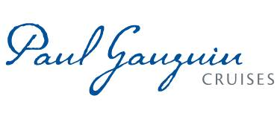
PAUL GAUGUIN CRUISES WINS “BEST TAHITI AND FRENCH POLYNESIA CRUISE LINE”
IN THE 2018 AFAR TRAVELERS’ CHOICE AWARDS

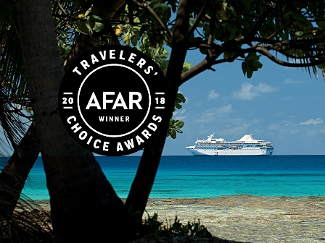

BELLEVUE, WASH. – October 17, 2018 – Paul Gauguin Cruises (www.pgcruises.com), operator of the highest-rated and longest continually sailing luxury cruise ship in the South Pacific, the m/s Paul Gauguin, is pleased to announce that it won the “Best Tahiti and French Polynesia Cruise Line” in the 2018 AFAR Travelers’ Choice Awards. This is the second consecutive year Paul Gauguin Cruises has won this award.

“Paul Gauguin Cruises sails year round in French Polynesia, and we are thrilled to receive this special award that celebrates our extraordinary voyages in this destination from AFAR magazine,” said Diane Moore, President, Paul Gauguin Cruises. “It is a testament to our talented team, which delivers exceptional service and experiences to our guests every day.”

AFAR magazine asks readers to vote for cruise lines, hotels, outfitters, and destinations that capture their imagination and inspire their travel plans in their annual Travelers’ Choice Awards. This year, AFAR readers cast close to 100,000 votes to recognize their favorite cruises. The full list of winners is available at www.afar.com, and the awards are featured in the November/December 2018 issue of AFAR magazine.

Paul Gauguin Cruises offers 7- to 14-night voyages in Tahiti, French Polynesia, and the South Pacific year round. Designed specifically to sail the pristine lagoons of the destination, The Gauguin provides an up-close, authentic experience of the South Seas and offers an elegant yet casual ambiance with luxurious accommodations, gourmet dining in three dining venues, trademark Polynesian hospitality, private beach retreats, and extraordinary all-inclusive value.

For more information or reservations, contact a professional travel agent, call 1-800-848-6172, or visit www.pgcruises.com.
###
About Paul Gauguin Cruises
Owned by Pacific Beachcomber S.C., French Polynesia’s leading luxury hotel and cruise operator, Paul Gauguin Cruises operates the 5+-star cruise ship, the 332-guest m/s Paul Gauguin, providing a deluxe cruise experience tailored to the unparalleled wonders of Tahiti, French Polynesia, and the South Pacific. Paul Gauguin Cruises has been recognized by notable publications in travel and lifestyle and was voted “#2 Midsize-Ship Ocean Cruise Line” by readers in the Travel + Leisure World’s Best Awards 2018†. The line was also recognized as one of the “Top Small Cruise Lines” in the Condé Nast Traveler 2018 Readers’ Choice Awards and is honored on the publication’s 2018 “Gold List.” Paul Gauguin Cruises was also selected as “Best Small-Ship Cruise Line” in Global Traveler’s Leisure Lifestyle Awards in 2016, 2017, and 2018, and received top honors as the “#1 Cruise Line for Honeymooners” in BRIDES Magazine’s 2017 Honeymoon Awards and was listed in the publication’s “Top All-Inclusives” in the 2018 Honeymoon Awards.
Media Contact:
Paul Gauguin Cruises
Vanessa Bloy, Director of Public Relations
(425) 440-6255/vbloy@pgcruises.com

†From Travel + Leisure Magazine, August 2018 © Time Inc. Affluent Media Group. Used under license. Travel + Leisure and Time Inc. Affluent Media Group are not affiliated with, and do not endorse products or services of, Paul Gauguin Cruises.

