m/s PAUL GAUGUIN ON CONDÉ NAST TRAVELER’S LIST OF TOP 20 SMALL CRUISE SHIPS
Voted by Readers in the Magazine’s Annual Poll of Top Cruise Ships of the World

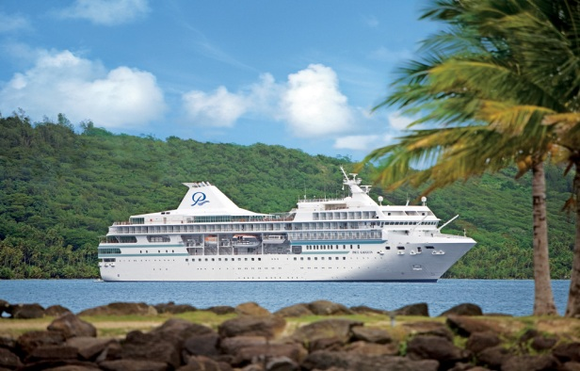
BELLEVUE, WASH. – February 23, 2012 – Paul Gauguin Cruises (www.pgcruises.com), operator of the highest-rated and longest continually sailing luxury cruise ship in the South Pacific, the m/s Paul Gauguin, is pleased to announce the selection of The Gauguin as one of the “Top 20 Small Cruise Ships” in 2012 by readers of Condé Nast Traveler magazine.

Readers rated cruise ships on a variety of criteria including itineraries/schedule, shore excursions, crew/service, cabins, food/dining, activities/facilities, and design/layout in the annual readers’ poll, which recognizes the “Top 100 Cruise Ships in the World.”

The full list of top cruise ships can be found on the magazine's website www.cntraveler.com and is also featured in the February 2012 issue of Condé Nast Traveler.

Paul Gauguin Cruises’ commitment to providing guests with the most luxurious and enriching cruise vacations to Tahiti, French Polynesia, and the South Pacific has consistently placed The Gauguin on the esteemed Condé Nast Traveler list 14 years in a row.
###
About Paul Gauguin Cruises
Owned by Pacific Beachcomber S.C., French Polynesia’s leading luxury hotel and cruise operator, Paul Gauguin Cruises operates the 5+-star cruise ship m/s Paul Gauguin, providing a deluxe cruise experience tailored to the unparalleled wonders of Tahiti, French Polynesia, and the South Pacific. The Gauguin was built at the Chantiers de l’Atlantique shipyard in Saint Nazaire, France. The ship, 513 feet long and 71 feet wide, has a draft of 16.9 feet and can accommodate 332 guests with a staff of 217. It is one of the top Exclusive Charter and Incentive Group venues in the industry and has completed more than 570 South Pacific cruises, serving more than 176,250 guests, including more than 15,000 honeymooners, since its inaugural sail in 1998. The Gauguin has undergone more than $25 million in enhancements, with an additional $7 million completed in January 2012. The Gauguin has been impressively named the 2011 Silver Magellan Award Winner in the Small Cruise Ship category by Travel Weekly and earned the “#1 ranking for Dining” in the Small Ship Category in Cruise Critic’s 2011 Cruisers’ Choice Awards.

Paul Gauguin Cruises also recently announced the acquisition of a second ship, which will begin sailing under the Paul Gauguin Cruises banner in December 2012. With plans to sail to Europe, the Caribbean, and Latin America, this ship will be christened m/v Tere Moana after completing a multifaceted renovation in December 2012. The Moana features 45 staterooms accommodating 90 guests.

For additional information on Paul Gauguin Cruises, please visit www.pgcruises.com.
Media Contact:
Paul Gauguin Cruises
Vanessa Bloy, Director of Public Relations
(425) 440-6255
vbloy@pgcruises.com

