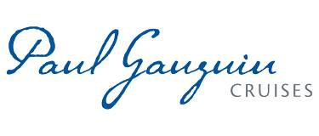
PAUL GAUGUIN CRUISES ANNOUNCES 2017 VOYAGES FEATURING NEW ITINERARIES
IN FIJI AND BALI PLUS POPULAR FAVORITES IN FRENCH POLYNESIA
AND COLLABORATION WITH WILDLIFE CONSERVATION SOCIETY

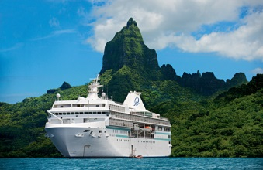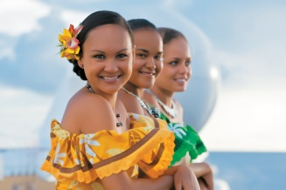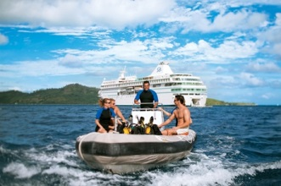

BELLEVUE, Wash. – January 5, 2016 – Paul Gauguin Cruises (www.pgcruises.com), operator of the highest-rated and longest continually sailing luxury cruise ship in the South Pacific, m/s Paul Gauguin, announces 2017 voyages that feature popular favorites along with new, exotic 16- and 17-night Fiji & Bali itineraries and a collaborative program with the Wildlife Conservation Society.

The 16-night Fiji to Bali voyage departs April 29, 2017, from Lautoka, Fiji, and visits Espiritu Santo, Vanuatu; Guadalcanal, Solomon Islands; Samarai Island, Papua New Guinea; Port Moresby, Papua New Guinea; Merauke, Indonesia; Dili, Timor-Leste; Komodo Island, Indonesia; Lembar, Lombok Island, Indonesia; and Benoa, Bali, Indonesia. The reverse itinerary, Bali to Fiji, is 17 nights and departs June 7, 2017.
In 2017, The Gauguin will also be showcasing its most sought-after itineraries: the 7-night Tahiti & the Society Islands; 7-night Tahiti, the Society Islands & Tuamotus; 10-night Society Islands & Tuamotus; 11-night Cook Islands & Society Islands; and 14-night Marquesas, Tuamotus & Society Islands. Also in 2017, the popular 12- and 13-night Society Islands, Cook Islands, Tonga & Fiji itineraries return. In addition to sailing to beautiful islands in the South Pacific, and showcasing Polynesian culture and hospitality, these voyages feature complimentary access to Paul Gauguin Cruises’ two exclusive retreats—Motu Mahana, an islet off the coast of Taha’a, and a private beach in Bora Bora. At Motu Mahana, guests enjoy a day of watersports, Polynesian activities, a barbecue feast, and cocktails from full-service and floating bars. In Bora Bora, guests can relax on a white-sand beach and enjoy refreshments, a game of volleyball, and snorkeling in crystal-clear waters.

On The Gauguin’s July 26, 2017, voyage, Paul Gauguin Cruises will present its third Reunion Cruise, which features a special 10-night Cook Islands & Society Islands itinerary with two visits to the line’s private island paradise of Motu Mahana. Designed as a reunion for past guests of Paul Gauguin Cruises and as a gala welcome for newcomers, it presents a number of unique special events, including a festive dinner, cocktail and block parties, opportunities to mingle with senior staff and crew, and more.

Paul Gauguin Cruises is also pleased to announce a new global collaboration with the Wildlife Conservation Society (WCS). WCS has been committed to saving wildlife and wild places worldwide since 1895. Beginning in 2017, WCS will offer educational programming for adults and families aboard The Gauguin. Our series will comprise lectures about marine science and wildlife conservation in the South Pacific and beyond. Additionally during the summer months and holiday season, WCS will inspire guests to value nature through our experiential family program. WCS aims to protect half of the world’s biodiversity, while ensuring a positive impact on millions of people. Paul Gauguin Cruises is proud to collaborate with WCS in support of a healthy and sustainable planet.
To launch its 2017 voyages, Paul Gauguin Cruises is offering savings of 50% off standard cruise fares on all 2017 voyages, plus included airfare from Los Angeles.

For rates or more information on Paul Gauguin Cruises, please contact a Travel Professional, call 800-848-6172, or
visit www.pgcruises.com.
###

About Paul Gauguin Cruises
Owned by Pacific Beachcomber S.C., French Polynesia’s leading luxury hotel and cruise operator, Paul Gauguin Cruises operates the 5+-star cruise ship, the 332-guest m/s Paul Gauguin, providing a deluxe cruise experience tailored to the unparalleled wonders of Tahiti, French Polynesia, and the South Pacific. Paul Gauguin Cruises accolades include being voted #2 in the category of “Top Small Cruise Lines” in the Condé Nast Traveler 2015 Readers’ Choice Awards and being honored on the publication’s esteemed 2016 Gold List. In addition, the line was voted by Travel + Leisure readers “#1 Small-Ship Cruise Line” and “#1 Small-Ship Cruise Line for Families” in the Travel + Leisure 2014 World’s Best Awards. Recently, readers voted Paul Gauguin Cruises “#2 Small-Ship Ocean Cruise Line” in the Travel + Leisure 2015 World’s Best Awards.†
Media Contact:
Paul Gauguin Cruises
Vanessa Bloy, Director of Public Relations
(425) 440-6255
vbloy@pgcruises.com

About WCS (Wildlife Conservation Society)
MISSION: WCS saves wildlife and wild places worldwide through science, conservation action, education, and inspiring people to value nature. To achieve its mission, WCS, based at the Bronx Zoo, harnesses the power of its Global Conservation Program in nearly 60 nations and in all the world’s oceans and its five wildlife parks in New York City, visited by 4 million people annually. WCS combines its expertise in the field, zoos, and aquarium to achieve its conservation mission. Visit: newsroom.wcs.org. Follow: @WCSNewsroom. For more information: 347-840-1242.
†From Travel + Leisure Magazine, August 2015 ©2015 Time Inc. Affluent Media. Used under license. Travel + Leisure and Time Inc. Affluent Media are not affiliated with, and do not endorse products or services of Paul Gauguin Cruises.

