PAUL GAUGUIN CRUISES OFFERS EXCLUSIVE “TAKE YOUR SWEETIE TO TAHITI” VALENTINE’S GIFT PACKAGE
On 2019 and 2020 Sailings Booked Between January 28 and February 16, 2019

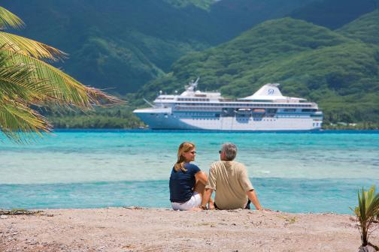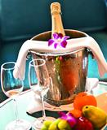

BELLEVUE, Wash. – January 28, 2019 – Paul Gauguin Cruises (www.pgcruises.com), operator of the highest-rated and longest continually sailing luxury cruise ship in the South Pacific, the m/s Paul Gauguin, is celebrating Valentine’s Day by offering an exclusive gift package* to guests on 2019 and 2020 sailings aboard The Gauguin who book between January 28 and February 16, 2019.

The Valentine’s gift package includes a $200 per-stateroom credit at the ship’s Deep Nature Spa by Algotherm, a box of chocolates, and a bottle of sparkling wine (total package valued at $250). This gift package is offered in addition to the line’s offer of 50% off standard all-inclusive cruise fares and included roundtrip airfare from Los Angeles or San Francisco.

At the Deep Nature Spa by Algotherm aboard The Gauguin, expert therapists and aestheticians offer an extensive menu of massages, skin care, facials, and authentic Polynesian treatments including Bora Bora Deep Blue Massages, Black Sand Body Scrubs, and Monoï Tradition Massages by Hei Poa, among a variety of other signature therapies and tropical treats.

The Gauguin is the perfect place to celebrate Valentine’s Day, a wedding, renewal of vows, anniversary—or simply each other. Couples can take in the beauty of the islands of French Polynesia from the privacy of their suite or stateroom, sway to the sounds of a chanteuse at La Palette Lounge, explore paradise on excursions by land and sea, dine al fresco under a starry sky, and enjoy a Polynesian blessing ceremony performed by members of Les Gauguines and Les Gauguins—the ship’s own troupe of Polynesian entertainers. With one of the highest crew-to-guest ratios at sea, The Gauguin is renowned for the extra touches and attention to detail that make every occasion special.

Paul Gauguin Cruises also offers wedding ceremony† and renewal of vows packages that allow couples sailing on The Gauguin to celebrate their love in a romantic setting amid the turquoise lagoons and exotic islands of French Polynesia. Choices include Motu Mahana, the cruise line’s private islet off the coast of Taha’a, and the luxurious InterContinental Bora Bora Resort & Thalasso Spa.

Additionally, Paul Gauguin Cruises has a Gift Registry, where guests commemorating their honeymoon, anniversary, or other milestone event can choose a “wish list” of gifts, ranging from shore excursions to spa options. Friends and family can visit the registry quickly and conveniently to select the gift (or gifts) they would like to give, and Paul Gauguin Cruises takes care of the rest.

For rates or more information on Paul Gauguin Cruises, please contact a Travel Professional, call 800-848-6172, or visit www.pgcruises.com.
###

*One Valentine’s Day gift package per booking. New bookings made between January 28-February 16, 2019, only. Please refer to promotion code: SWEETIE2019. Combinable with one other Shipboard Credit offer, but not combinable with Groups, Two-Week Sales, and other select reduced-rate offers. Sparkling wine available on first night of sailing only. Offer expires February 16, 2019, and can be withdrawn at any time. Call for details.

†Wedding ceremony is not legally binding.

About Paul Gauguin Cruises
Owned by Pacific Beachcomber S.C., French Polynesia’s leading luxury hotel and cruise operator, Paul Gauguin Cruises operates the 5+-star cruise ship, the 332-guest m/s Paul Gauguin, providing a deluxe cruise experience tailored to the unparalleled wonders of Tahiti, French Polynesia, and the South Pacific. Paul Gauguin Cruises has been recognized by notable publications in travel and lifestyle and was voted “#2 Midsize-Ship Ocean Cruise Line” by readers in the Travel + Leisure World’s Best Awards 2018**. The line was also recognized as one of the “Top Small Cruise Lines” in the Condé Nast Traveler 2018 Readers’ Choice Awards and is honored on the publication’s 2018 “Gold List.” Paul Gauguin Cruises was also selected as “Best Small-Ship Cruise Line” in Global Traveler’s Leisure Lifestyle Awards in 2016, 2017, and 2018, and received top honors as the “#1 Cruise Line for Honeymooners” in BRIDES Magazine’s 2017 Honeymoon Awards and was listed in the publication’s “Top All-Inclusives” in the 2018 Honeymoon Awards.

Media Contact:
Vanessa Bloy
Paul Gauguin Cruises
Director of Public Relations
(425) 440-6255
vbloy@pgcruises.com

**From Travel + Leisure Magazine, August 2018 © Time Inc. Affluent Media Group. Used under license. Travel + Leisure and Time Inc. Affluent Media Group are not affiliated with, and do not endorse products or services of, Paul Gauguin Cruises.

